**PROJECT REPORT**

*TITLE:*

**MONGODB DEEP DIVE**

COURSE:

**ADVANCED DATABASE MANAGEMENT**

**MET CS 779**

BY:

**Vijay Nagaraj Karigowdara**

**BU ID: U17429935**

# **ABSTRACT**

This project involves research on the document-oriented database MongoDB. The research involves various tasks like exploring the database features, executing the query operations, comparison with relational database mainly Oracle, exploration and demonstration by executing special queries using GridFs, Geospatial, MapReduce etc. which are specific to MongoDB, creating and deploying database in local and cloud, exploring the products and tools offered by MongoDB, creating an API which interacts with MongoDB and developing a simple website called ‘Blog’ designed in HTML and JavaScript which utilizes the cloud MongoDB to store data.

# 

# 

# 

# 

# 

# 

# 

# 

# 

# **INTRODUCTION**

As MongoDB Inc reports, “MongoDB is an open-source document database that provides high performance, high availability, and automatic scaling. A record in MongoDB is a document, which is a data structure composed of field and value pairs. MongoDB documents are similar to JSON objects. The values of fields may include other documents, arrays, and arrays of documents” (MongoDB Manual 4.0).

Sample document: -

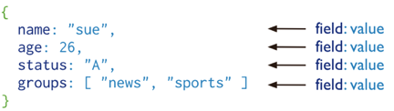

# **KEY FEATURES**

1. **High Performance**

* MongoDB supports embedded data models and reduces I/O activity on database system.
* Indexes in MongoDB support faster queries and can include keys from embedded documents and arrays.

1. **High Availability**

* MongoDB database adapts Master and Slave replication technique.
* A master is able to perform Reads and Writes and a Slave copies the data from master and can only be used for reads or back up but not writes.
* MongoDB’s replication facility called [*r*](https://docs.mongodb.com/manual/replication/)*eplica set,* provides automatic failover and data redundancy.

1. **Rich Query Language**

* MongoDB supports a rich query language to support read and write operations (CRUD) as well as aggregation.
* The aggregation pipeline is a framework for data aggregation modeled on the concept of data processing pipelines. Documents enter a multi-stage pipeline that transforms the documents into aggregated results.

**4. Horizontal Scalability**

* Supports sharding which allows distribution of data across a cluster of machines.
* Starting from version 3.4, MongoDB supports creating zones of data based on the shard key. In a balanced cluster, MongoDB directs reads and writes covered by a zone only to those shards inside the zone.

(The above key features are cited from MongoDB manual 4.0.)

# **TERMINOLOGIES**

**Database**:

In MongoDB, a database is a physical container for collections. Each database gets its own set of files on the file system. A single MongoDB server typically has multiple databases.

**Collection:**

Collection is a group of MongoDB documents. It is the equivalent of an RDBMS table. A collection exists within a single database. Collections do not enforce a schema. Documents within a collection can have different fields. Typically, all documents in a collection are of similar or related purpose.

**Document:**

A document is a set of key-value pairs. Documents have dynamic schema. Dynamic schema means that documents in the same collection do not need to have the same set of fields or structure, and common fields in a collection's documents may hold different types of data.

The following table shows the relationship of RDBMS terminology with MongoDB.

|  |  |
| --- | --- |
| **SQL** | **MongoDB** |
| Table | Collection |
| Row | Document |
| Column | Field |
| JOINs | Embedded documents, $lookup & $graphLookup |
| GROUP_BY | Aggregation Pipeline |

Following example shows the sample document structure, which is simply a comma separated key value pair.

{ _id: ObjectId(7df78ad8902c)  
 title: 'MongoDB Deep Dive',   
 description: 'MongoDB is NOSQL document based database',  
 by: ‘Mongo DB',  
 url: 'http://mongodb.com',  
 tags: ['mongodb', 'database', 'NoSQL'],  
 likes: 100,   
 comments: [   
 { user:'Vijay',  
 message: 'My first comment',  
 dateCreated: new Date(2018,1,20,2,15),  
 like: 0 },

{user:'Jack',  
 message: 'My second comments',  
 dateCreated: new Date(2018,1,25,7,45),  
 like: 5 }  
 ]  
}

Theattribute ***_id*** is a 12 bytes hexadecimal number. It can be provided while inserting the document. If _id attribute is not provided, then MongoDB provides a unique id for every document. The 12 bytes of _id attribute is divided into 4 parts, first 4 bytes for the current timestamp, next 3 bytes for machine id, next 2 bytes for process id of MongoDB server and last 3 bytes are incremental VALUE.

(The above terminologies are cited from the section of MongoDB Overview, <https://www.tutorialspoint.com/mongodb/mongodb_overview.htm> ).

# **COMPARISON WITH SQL**

The following table shows all the CRUD operation queries compared with SQL and MongoDB cited from MongoDB documentation Manual, 4.0 (<https://docs.mongodb.com/manual/reference/sql-comparison/>). The below comparison includes few important examples.

**Create/ Alter Queries: -**

|  |  |
| --- | --- |
| **Oracle** | **MongoDB** |
| CREATE TABLE employee (id NOT NULL  AUTO_INCREMENT,  user_id Varchar(20),  age Number,  status char(1),  PRIMARY KEY (id));  INSERT INTO employee (user_id,age, status) VALUES ("001", 15, "Active") | db. employee.insertOne({ user_id: "001", age: 15, status: "Active" });  db.createCollection("employee ");  db.createCollection( "products", { capped: true, size: 100 });  db.products.insertMany( [ { item: "card", qty: 15 },  { item: "envelope", qty: 100 },  { item: "stamps" , qty: 200 }] ); |
| ALTER TABLE employee DROP COLUMN join_date; | db.employee.updateMany({ },  { $unset: { "join_date": "" } }); |
| CREATE INDEX idx_user_id_asc ON employee (user_id) | db.employee.createIndex( { user_id: 1 } ); |
| DROP TABLE people | db.employee.drop(); |

**Select Queries: -**

|  |  |
| --- | --- |
| **Oracle** | **MongoDB** |
| SELECT * FROM employee; | db.employee.find(); |
| SELECT user_id, status FROM employee WHERE status = "A" | db.employee.find({ status: "A" },{ user_id: 1, status: 1, _id: 0 }) |
| SELECT * FROM employee WHERE status = "M" OR age = 30 | db.employee.find({ $or:[ { status: "M" } ,{ age: 30 } ] }) |
| SELECT * FROM employee WHERE age > 15 AND age <= 20 | db.employee.find( { age:{ $gt:15, $lte: 20 } }) |
| SELECT * FROM employee WHERE user_id like "%bc%" | db.employee.find( { user_id: /^bc/ } )  db.employee.find( { user_id: { $regex: /^bc/ } } ) |
| SELECT * FROM employee WHERE user_id like "bac%"; | db.employee.find( { user_id: { $regex: /^bac/ } } ); |

|  |  |
| --- | --- |
| **Oracle** | **MongoDB** |
| SELECT * FROM employee WHERE status = "I" ORDER BY user_id ASC; | db.employee.find( { status: "I" } ).sort( { user_id: 1 } ); |
| SELECT COUNT(*) FROM employee; | db.employee.count(); -or- db. employee.find().count(); |
| SELECT COUNT(user_id) FROM employee; | db.employee.count( { user_id: { $exists: true } } ); -or-  db.employee.find( { user_id: { $exists: true } } ).count() |
| SELECT DISTINCT(status) FROM employee; | db. employee.aggregate( [ { $group : { _id : "$status" } } ]); |
| SELECT * FROM employee LIMIT 5 SKIP 10; | db.employee.find().limit(5).skip(10); |
| EXPLAIN SELECT * FROM employee WHERE status = "A; | db.employee.find( { status: "A" } ).explain(); |

**Update/Delete Queries: -**

|  |  |
| --- | --- |
| **Oracle** | **MongoDB** |
| UPDATE employee SET status = "M" WHERE age > 25 | db.employee.updateMany({ age: { $gt: 25 } },  { $set: { status: "M" } }); |
| UPDATE employee SET age = age + 10 WHERE status = "I"; | db.employee.updateMany({ status: "I" } ,{ $inc: { age: 10} }); |
| DELETE FROM employee WHERE status = "I"; | dbemployee.deleteMany( { status: "I" } ); |
| DELETE FROM employee; | db.employee.deleteMany({}); |

# **MongoDB GridFS**

According to MongoDB, “GridFS is a specification for storing and retrieving files that exceed the BSON-document size limit of 16 MB” (MongoDB Manual, 4.0. GridFS). Large files like images, audio files, video files can be stored into GridFS. GridFS divides the storing file into chunks and stores each chunk of data in a separate document. Each document has a size of 255 kb.

By default GridFS uses two collections ***fs.files,*** to store the file's metadata and ***fs.chunks*** to store the chunks of data. Each chunk has an unique _id ObjectId field. The fs.files serves as a parent document. The files_id field in the fs.chunks document links the chunk to its parent.

Example: -

1. Navigate to the local mongodb installation path where the mongofiles executable file is present.

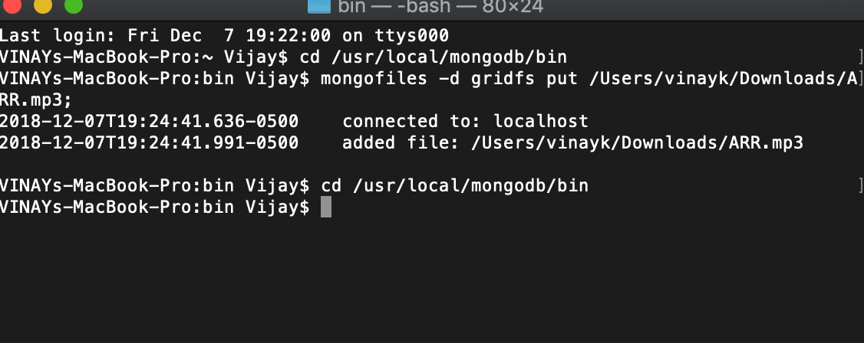

1. Executing below command to store the file into the database.

(Choosing an ARR.mp3 file with size of 22 MB)

mongofiles -d gridfs put /Users/vinayk/Downloads/ARR.mp3

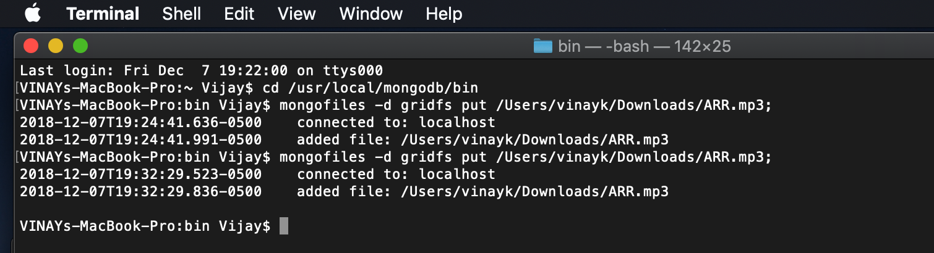

The file ARR.mp3 has been added by creating a new database called ***gridfs*** (show below). The above command creates 2 collections.

* ***fs.chunks*** having data divided into chunks of 255k each.
* ***fs.files*** having metadata of all the files stored.

3. Checking the storage of the file with below commands for fetching file and chunk data (Used Studio 3T tool for better visualization of data).

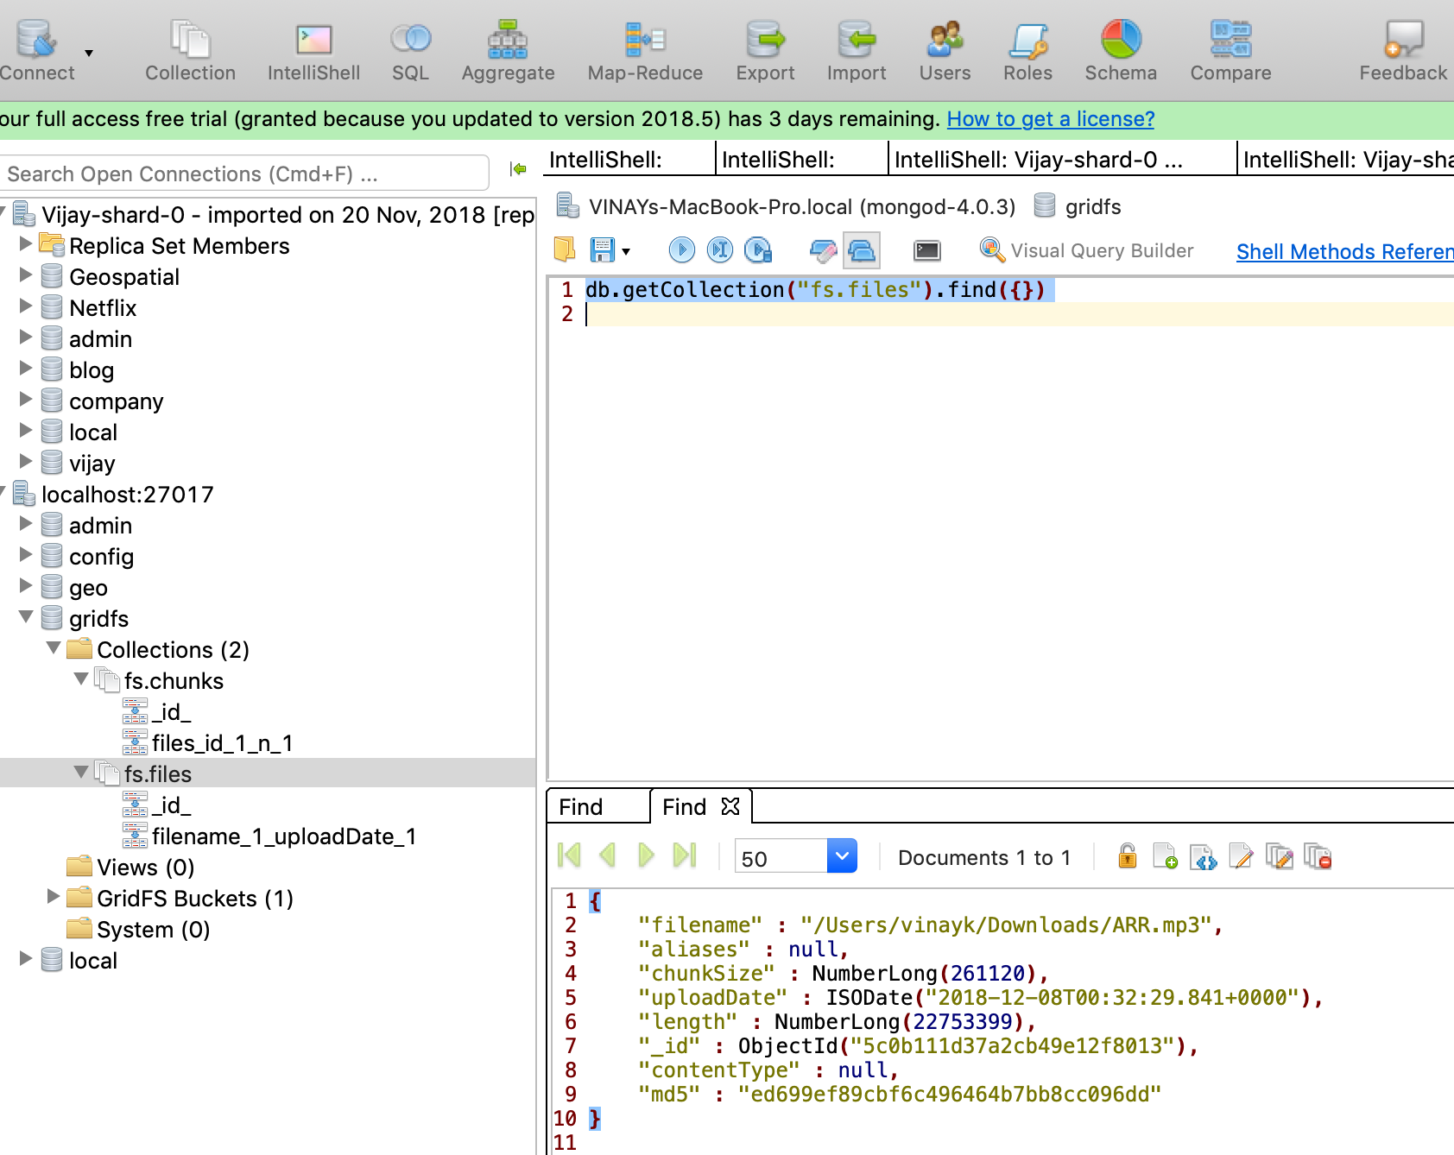

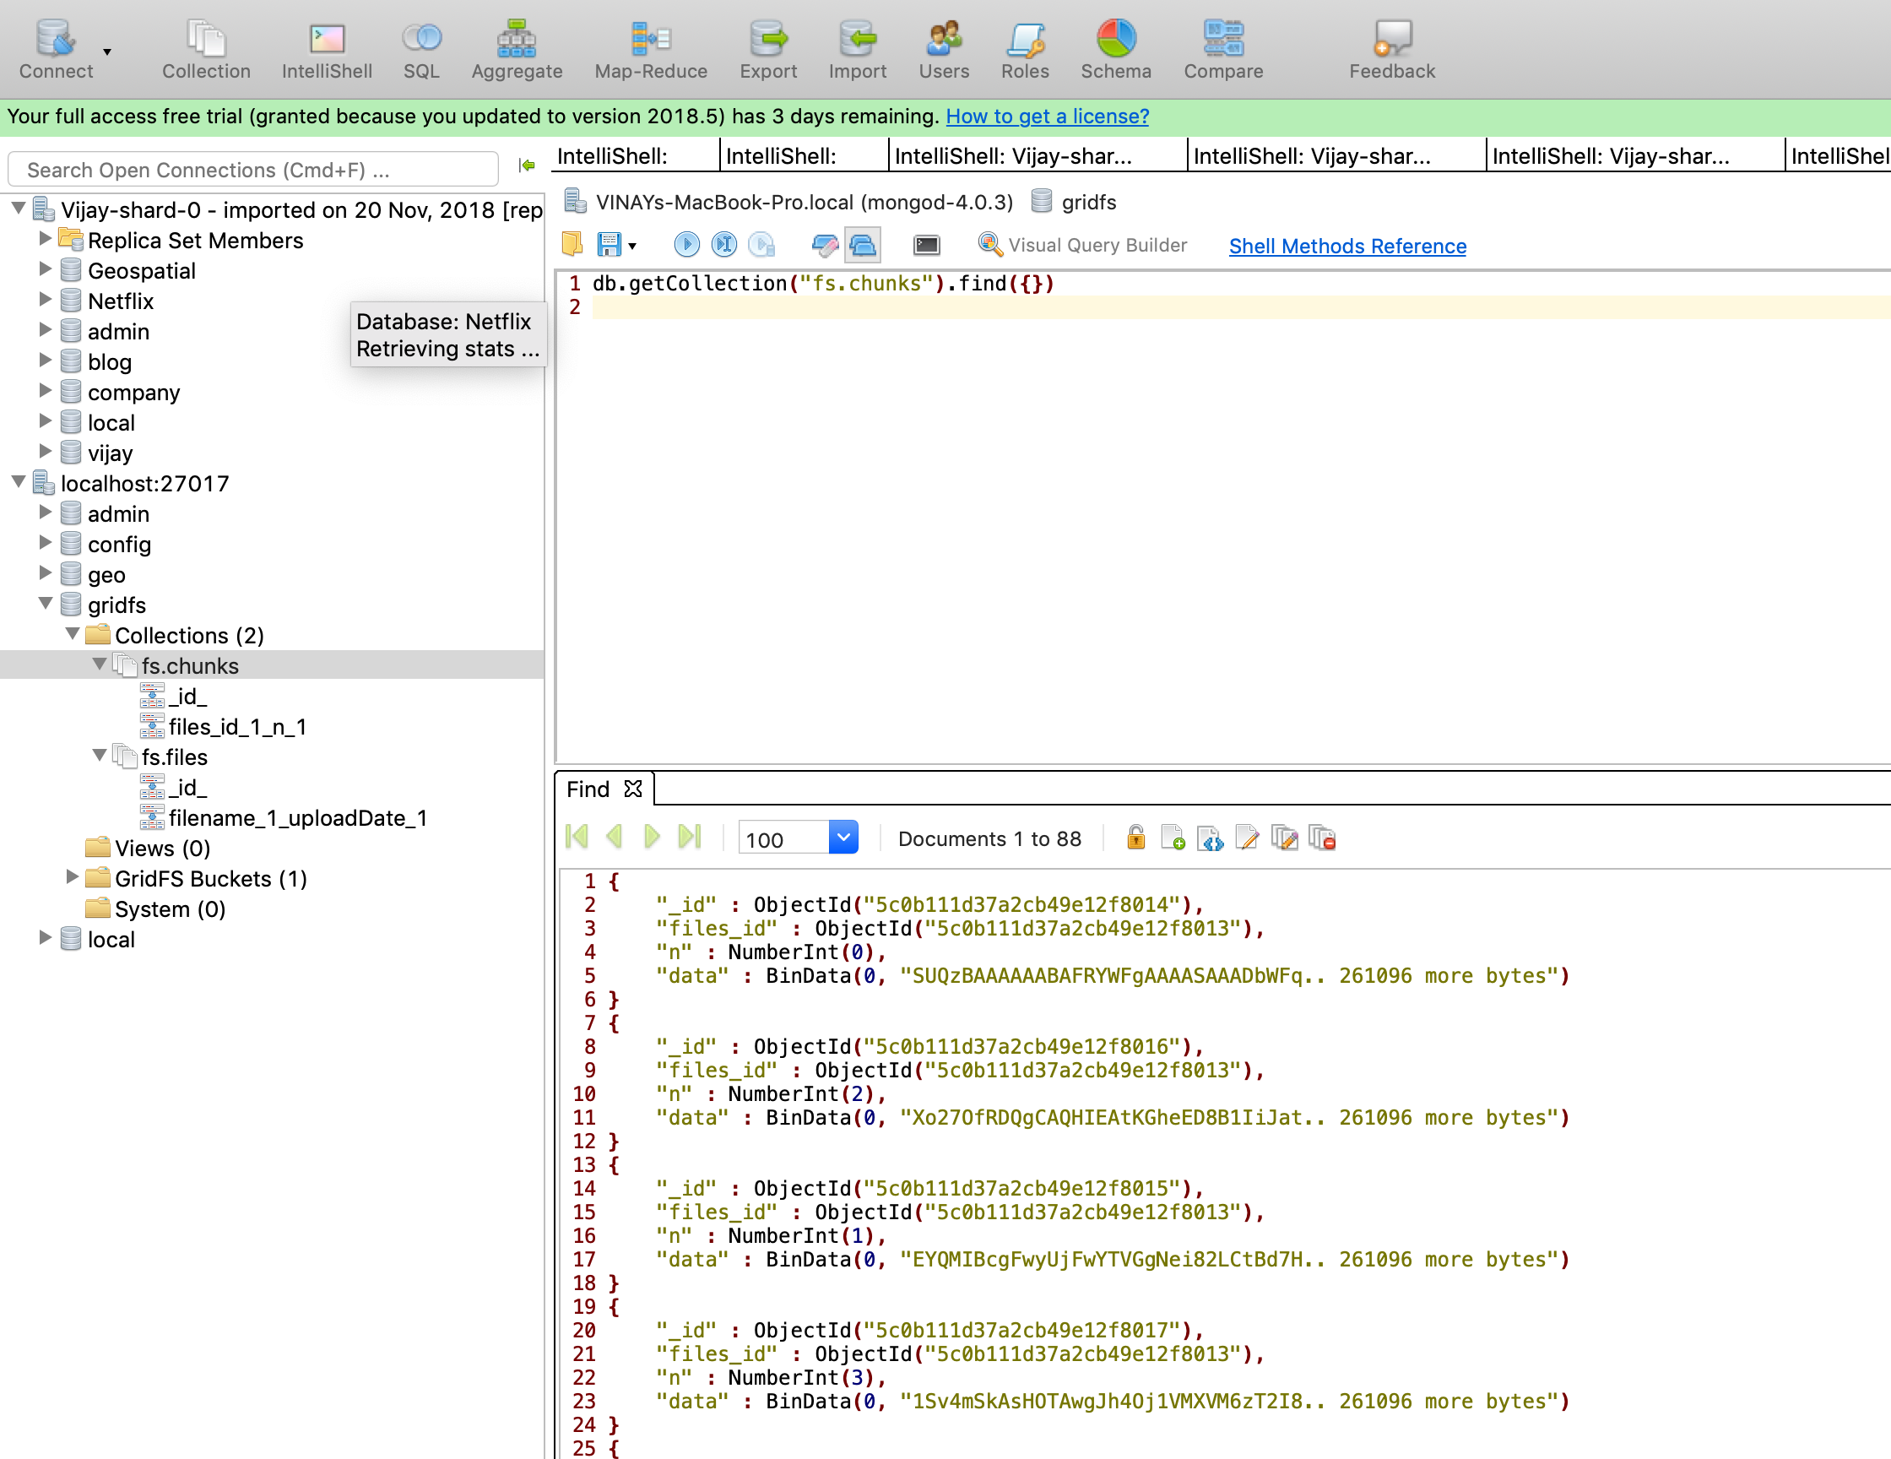

As observed above, the query fetched 88 documents (chunks) stored in BinData format (Binary data)

4. Deleting the file from the database.

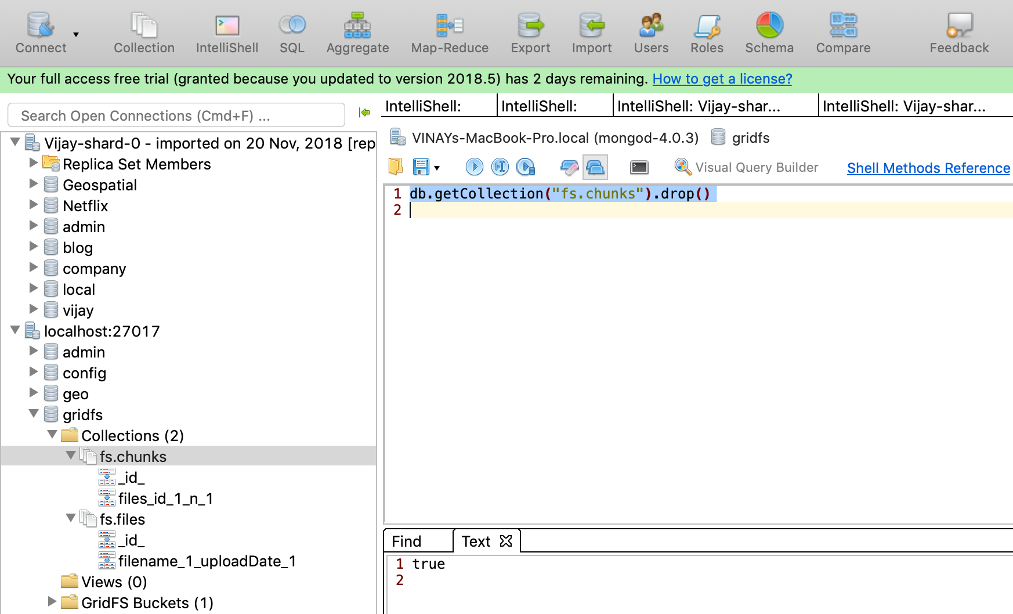

The above command removed all the chunk files, similarly file metadata is removed by replacing name *fs.chunks* with *fs.files* in the above command.

# **MongoDB ATLAS**

As MongoDB reports, “MongoDB Atlas is a fully-managed cloud database developed by MongoDB. Atlas handles all the complexity of deploying, managing, and healing your deployments on the cloud service provider of any choice (AWS, Azure, and GCP)” (MongoDB Manual, MongoDB Atlas).

Creating an Atlas Account:

The cluster is built using AWS cloud provider by choosing appropriate cluster tier as shown below.

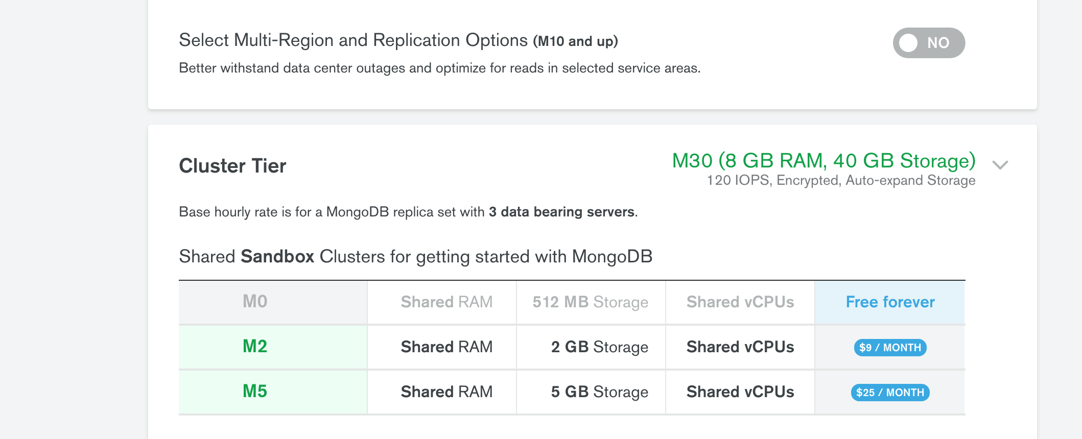

After creating cluster

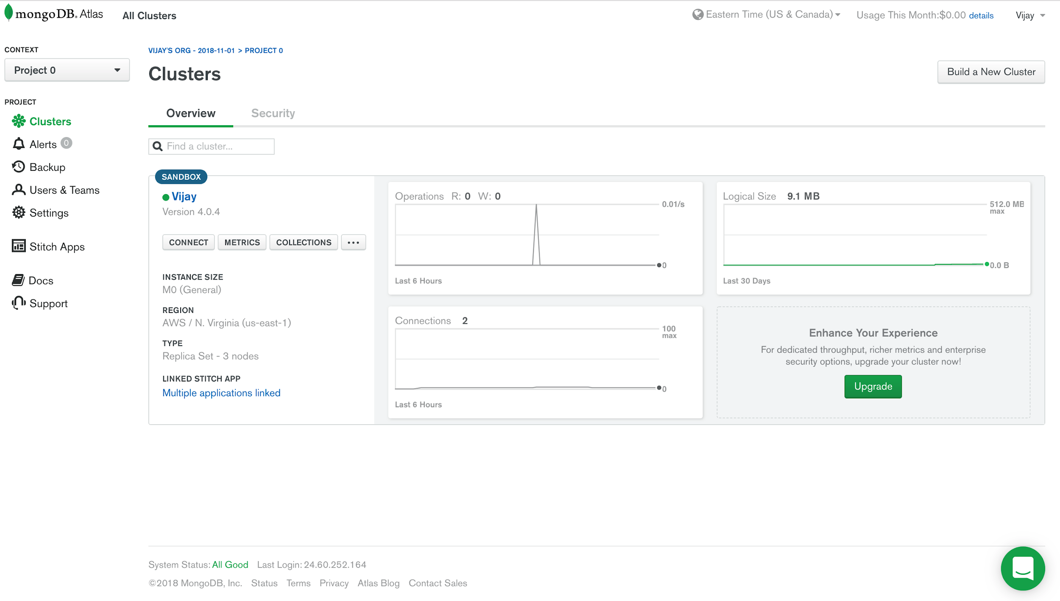

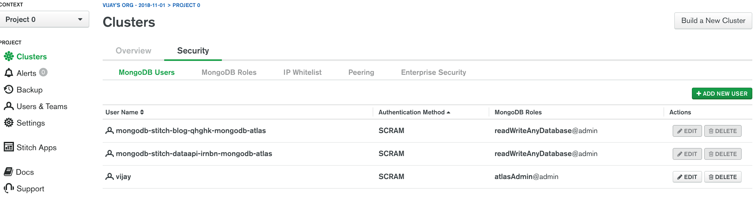

In the Security tab, we can add the users of the cluster and provide roles like read, write, admin etc. to the users. The above screenshot shows 3 users, one with name “*vijay*” having privilege of Admin and the other 2 are created as I have developed 2 MongoDB Stitch apps which utilizes this cluster, so those users are added by default.

After creating the cluster, navigating to the home page and selecting collections provides us to create database and collections as shown below.

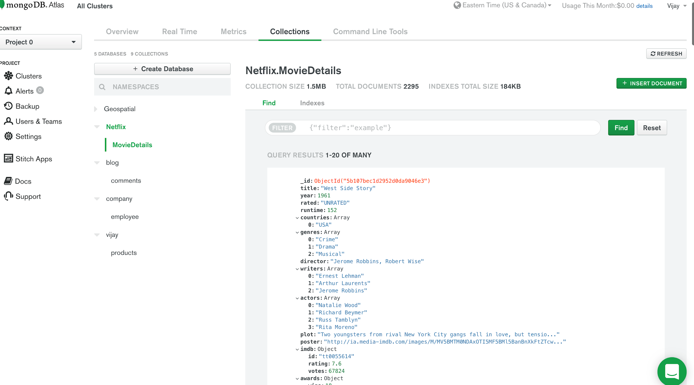

The above details show Netflix database having movieDetails collection. The collection is obtained from the MongoDB website with below link.

<https://raw.githubusercontent.com/steveren/docs-assets/charts-tutorial/movieDetails.json>

The data is imported to the database by connecting the cluster to the MongoDB tool named Compass.

# **MongoDB COMPASS**

As MongoDB reports, “MongoDB compass is the Graphical User Interface (GUI) for MongoDB. Compass provides users with a graphical view of their MongoDB schema by randomly sampling a subset of documents from the collection. Sampling documents minimizes performance impact on the database and can produce results quickly. It allows users to easily analyze and understand the contents of their data collections within MongoDB and perform queries, without requiring knowledge of MongoDB query syntax” (MongoDB documentation, MongoDB Compass).

Tool Features: -

* View, add, and delete databases and collections.
* Build and run ad hoc queries.
* View and optimize query performance with visual explain plans.
* Indexes can be managed Manage indexes: view stats, create, and delete.
* Create and execute aggregation pipelines.

Connecting Compass to Atlas Cloud:

By selecting *connect* from cluster home, we can connect with MongoDB Compass by using connection URI string as shown below.

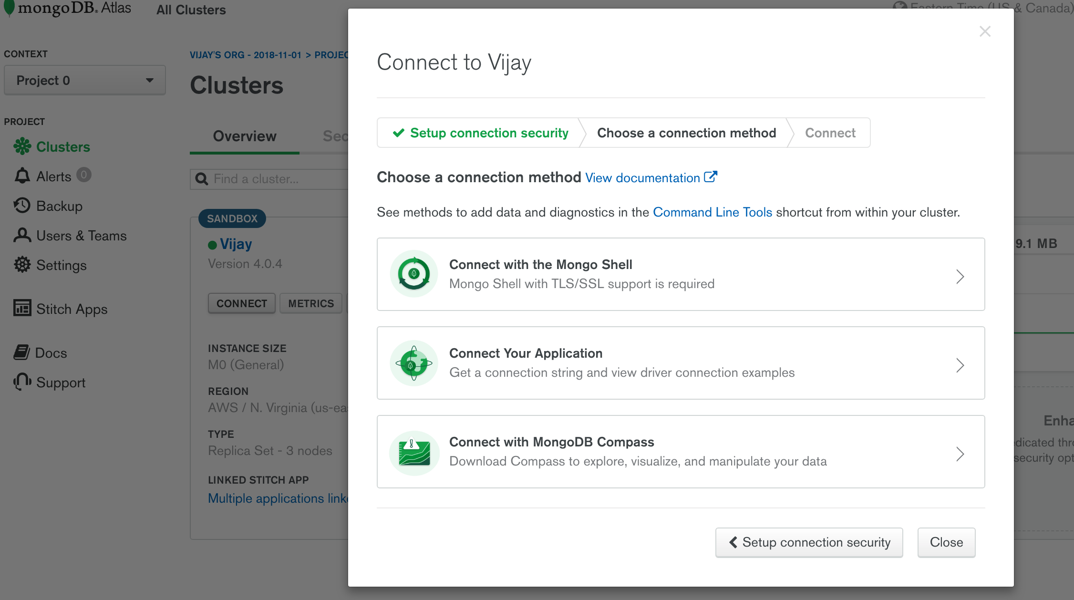

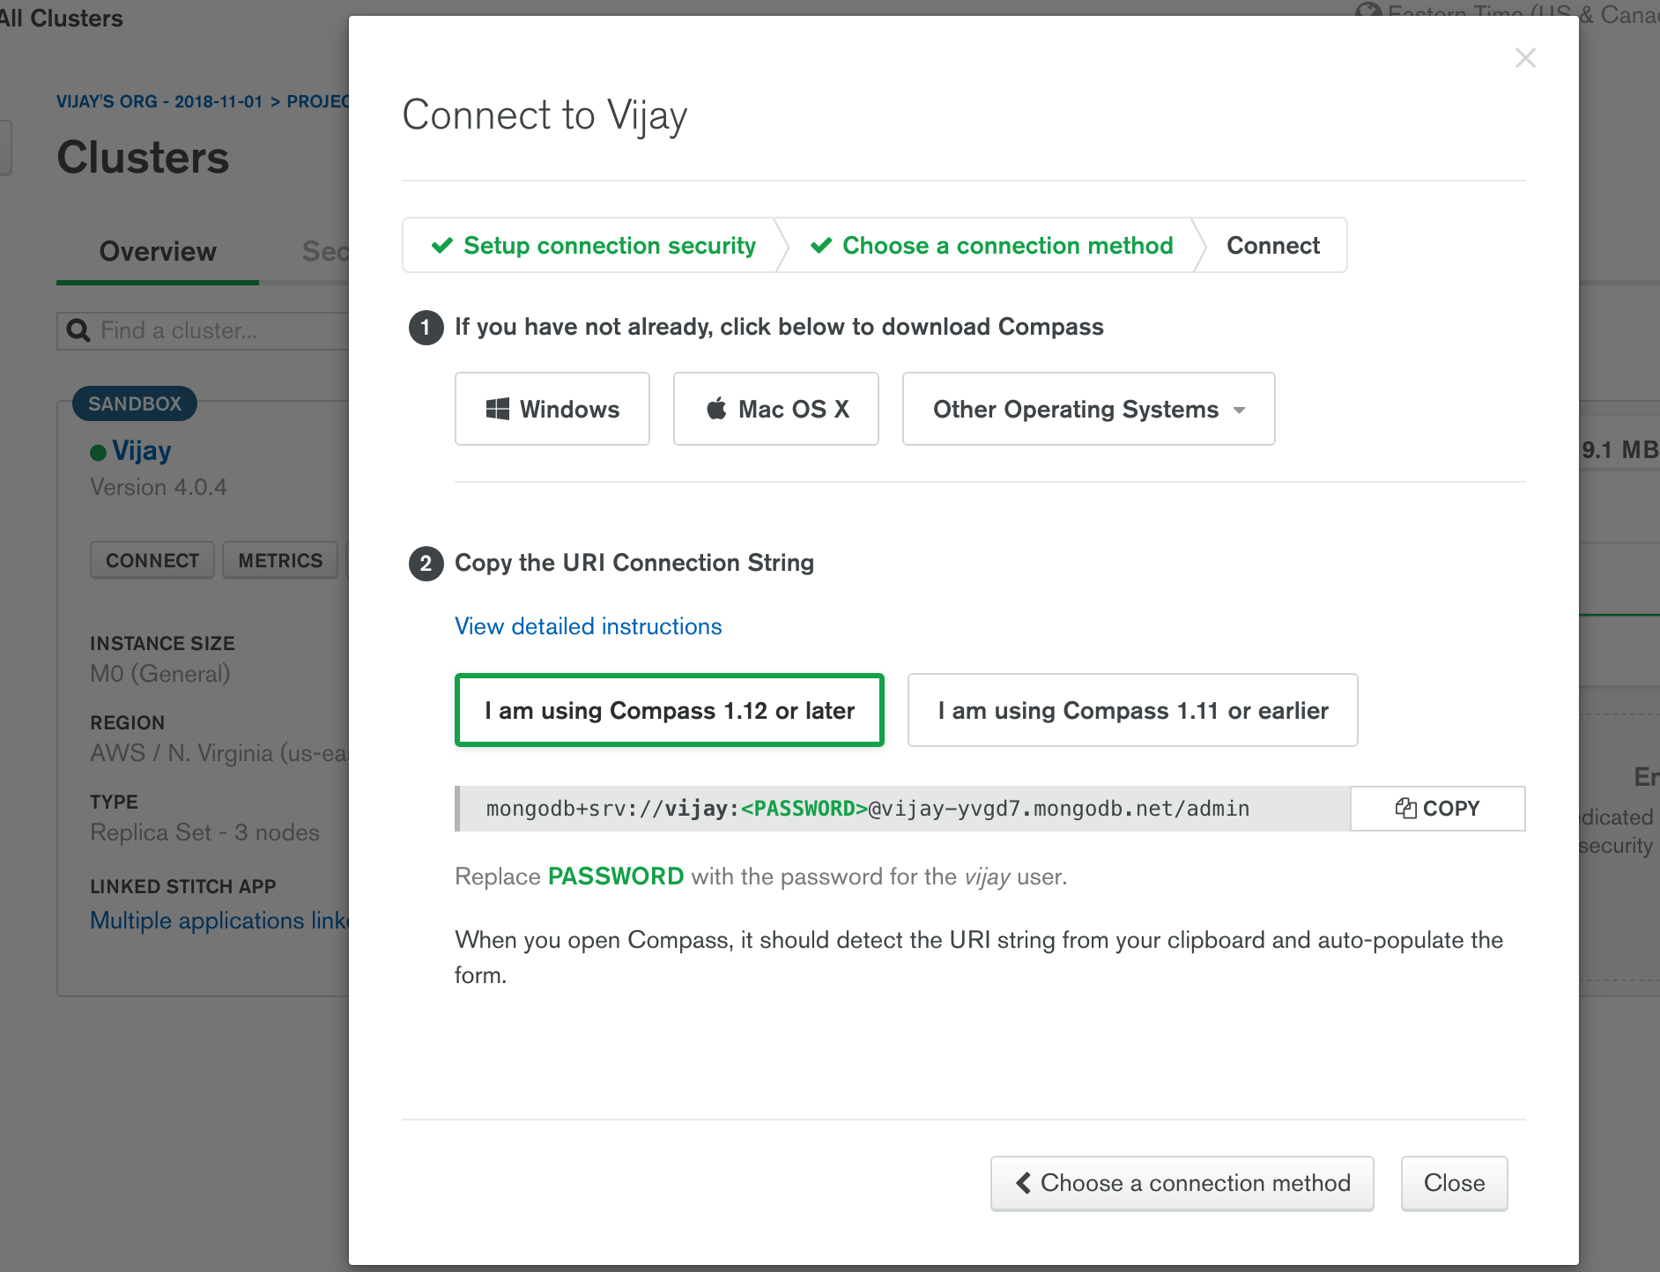

Once the Compass tool is installed in the machine, we can connect to the cluster by providing hostname and credentials as shown below.

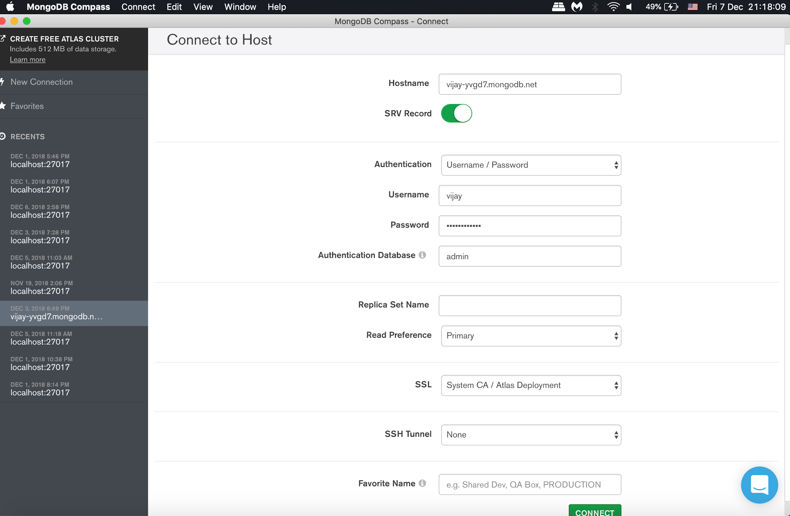

After connecting with cluster as shown below, we can work with Compass tool to create and manage data.

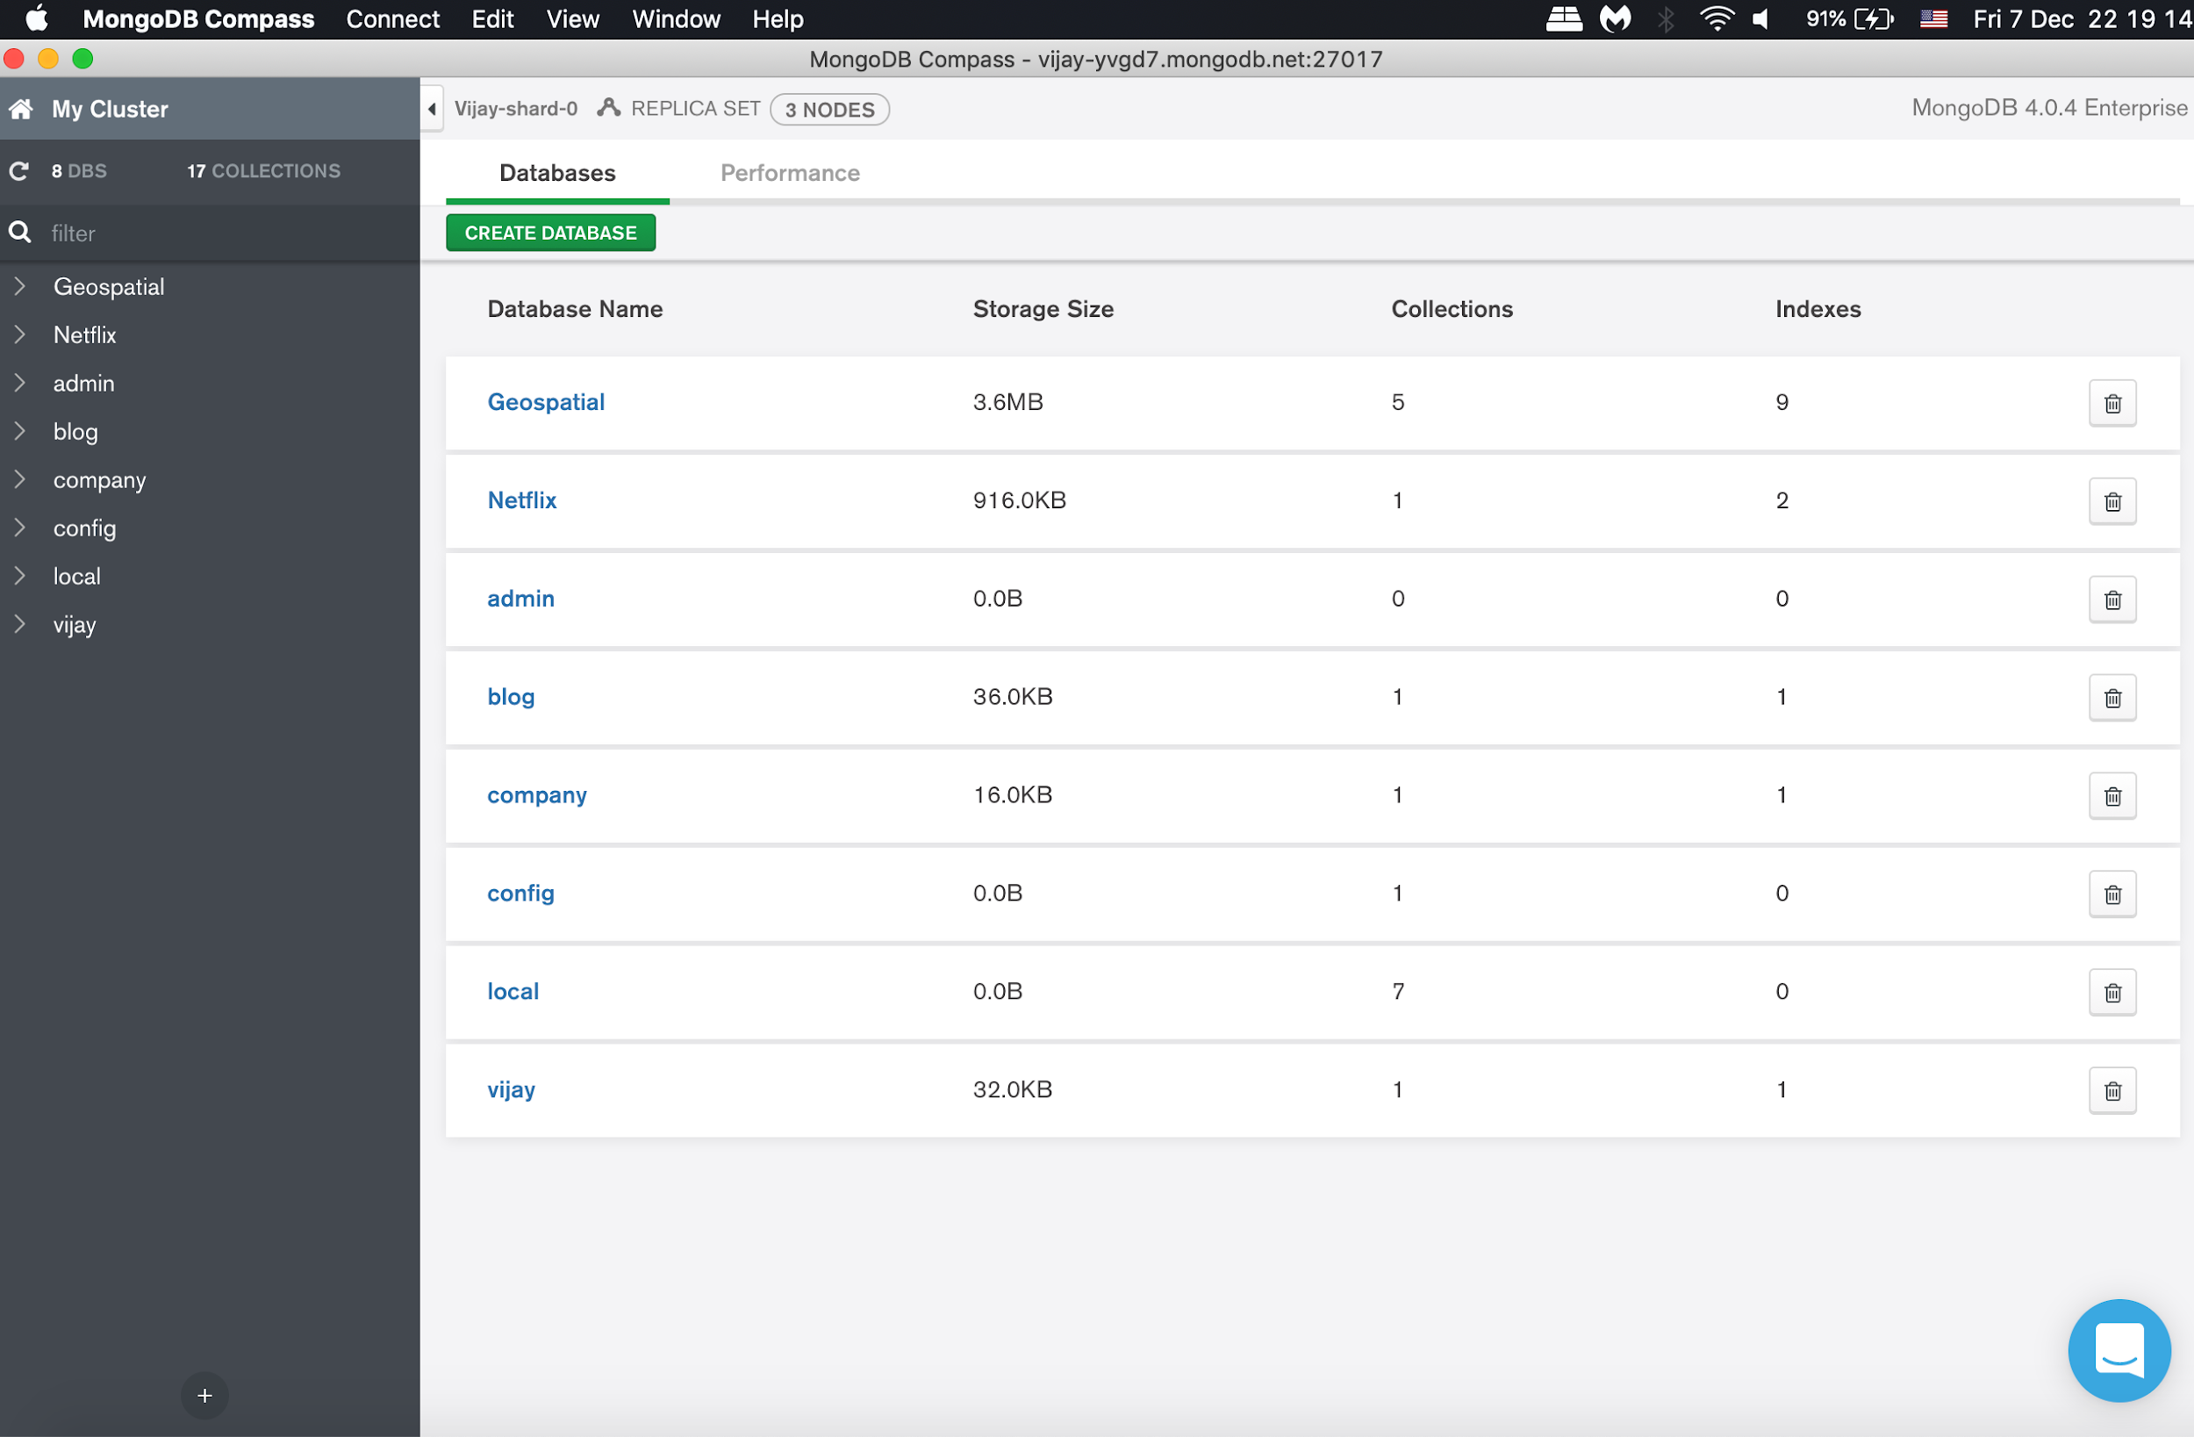

I have imported MoviDetails collection into Netflix database to visualization data in the tool.

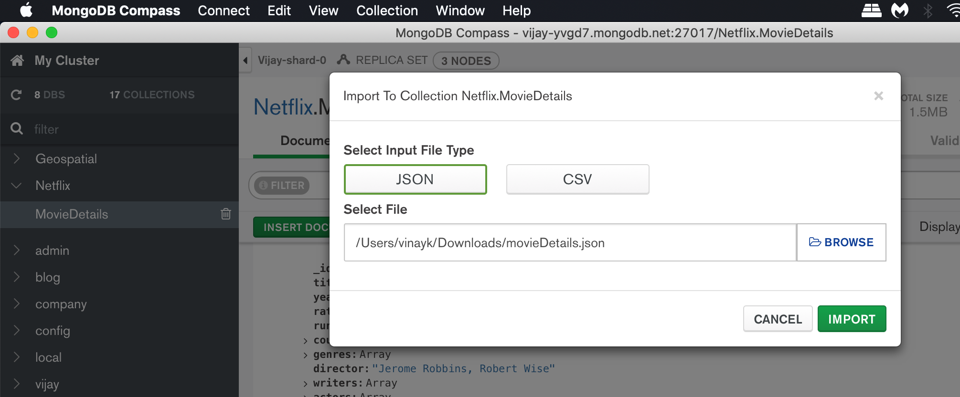

Visualization of data:

Table view: -

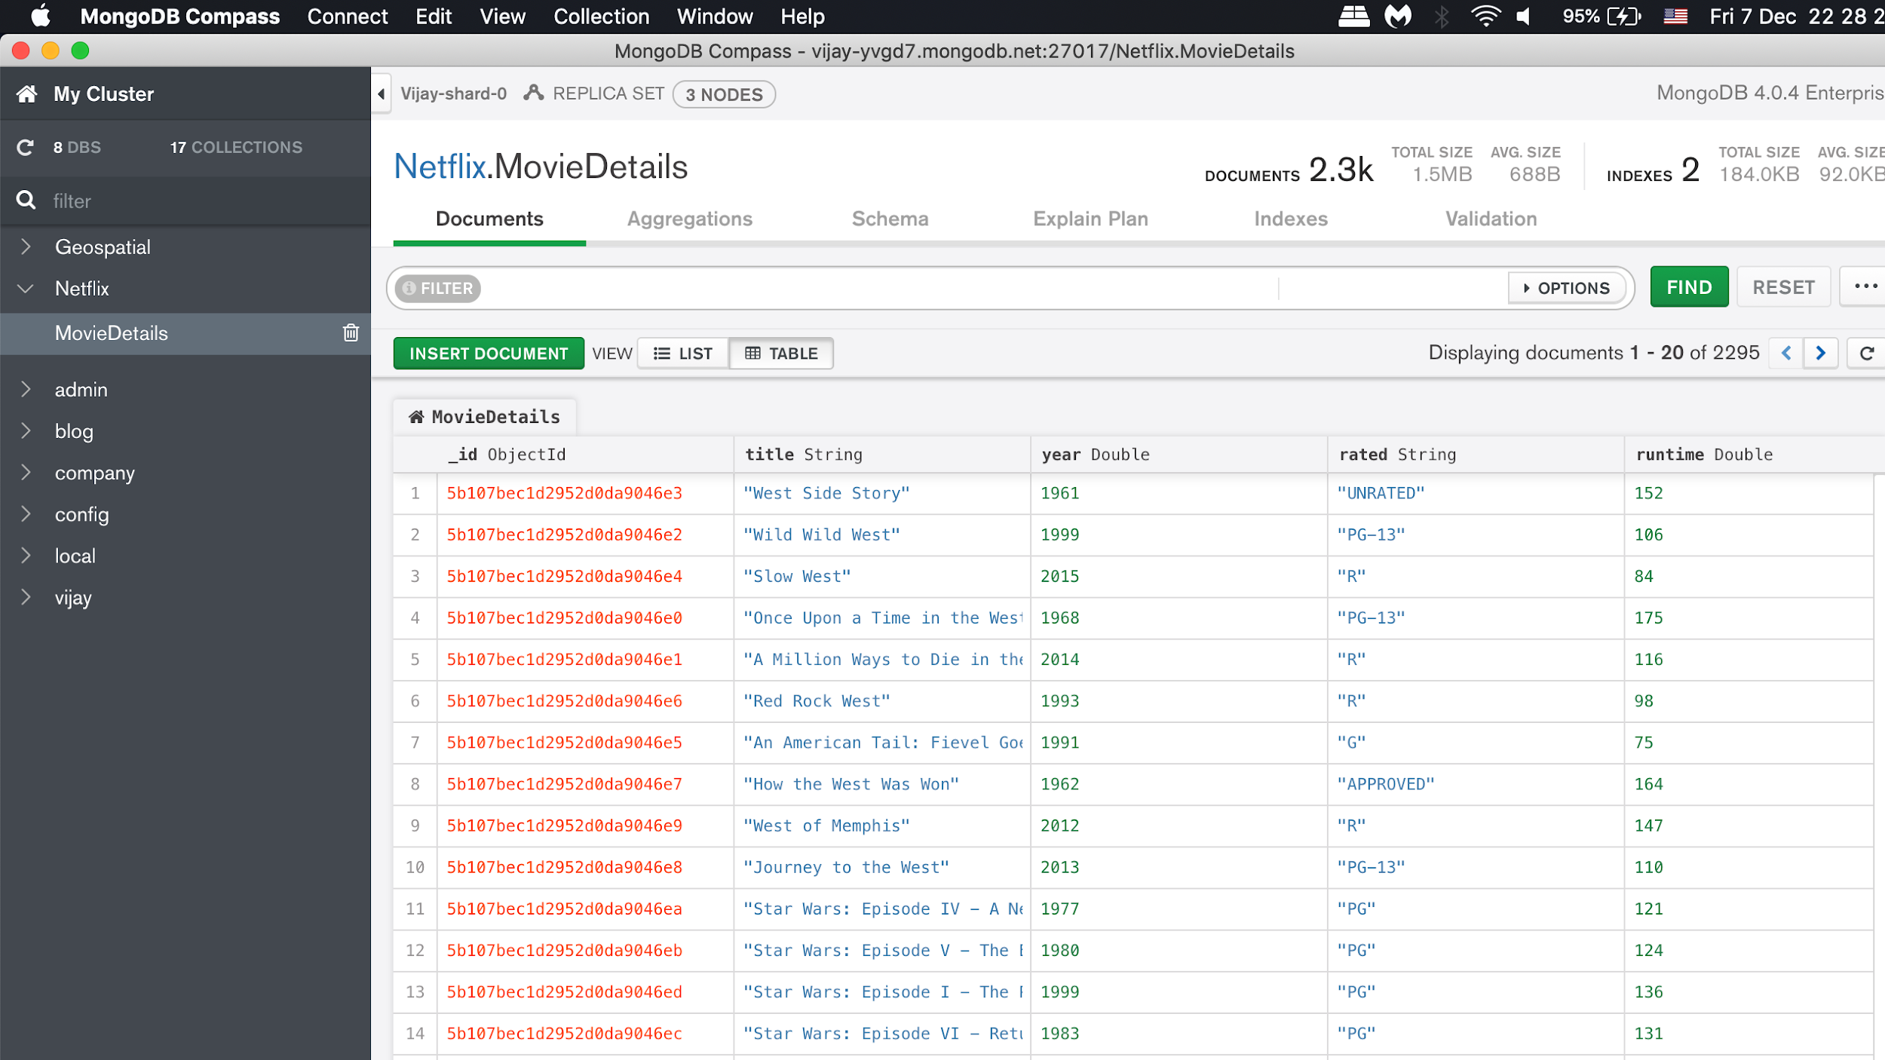

List view: -

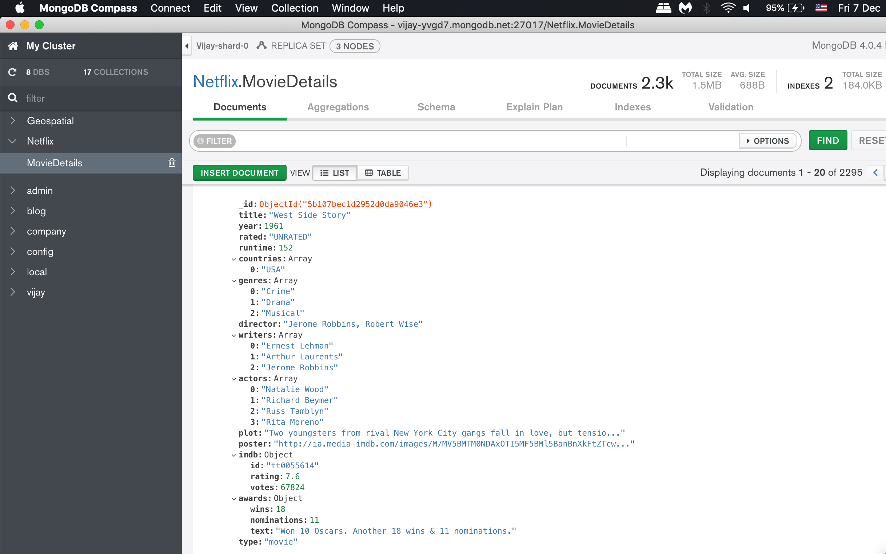

From the Documents tab, we can view, insert, clone, modify, and delete documents. Query bar can be used to specify MongoDB queries to return a subset of documents from the collection.

According to MongoDB, “For any query result sets larger than 1000 documents, Compass shows a sampling of the results. Otherwise, Compass shows the entire result set. Sampling in MongoDB Compass is the selection a subset of data from a particular collection and analyzing the documents within the sample set. Sampling is a common technique in statistical analysis because analyzing a subset of the data gives similar results to analyzing all of it. In addition, sampling allows results to be generated quickly rather than performing a computationally-expensive collection scan” (MongoDB documentation, MongoDB Compass, Schema).

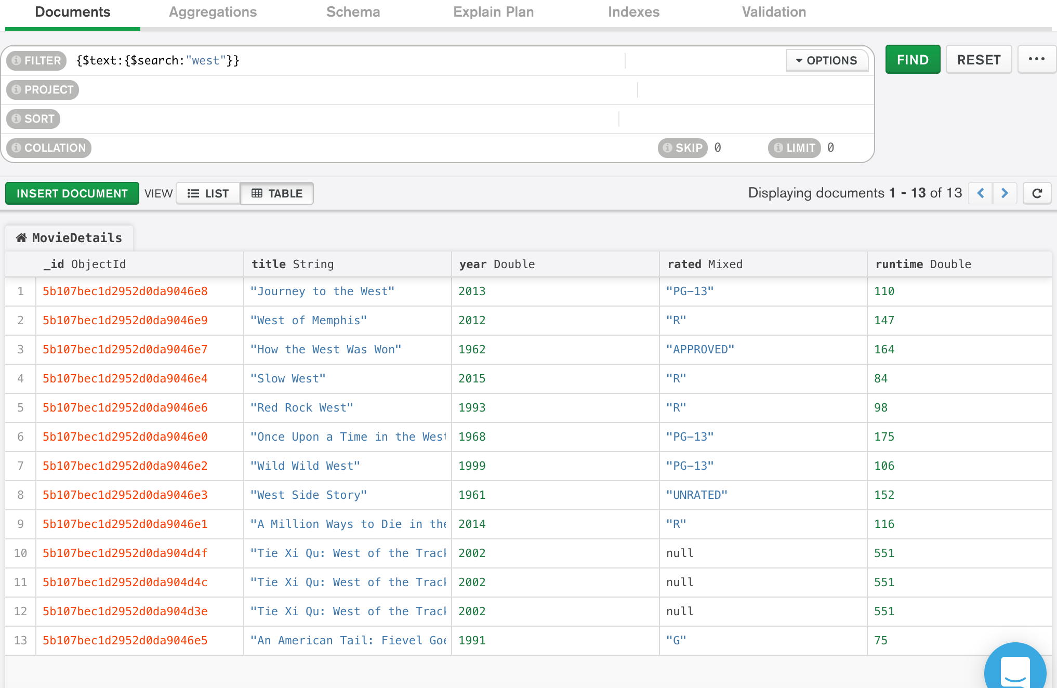

The above query returned 13 documents having title containing name “west”. In order to execute text search queries in MongoDB, the field that is searched has to be indexed.

db.MovieDetails.ensureIndex({title:"text"});

The query can be exported to other languages like Python, Node, C and Java.

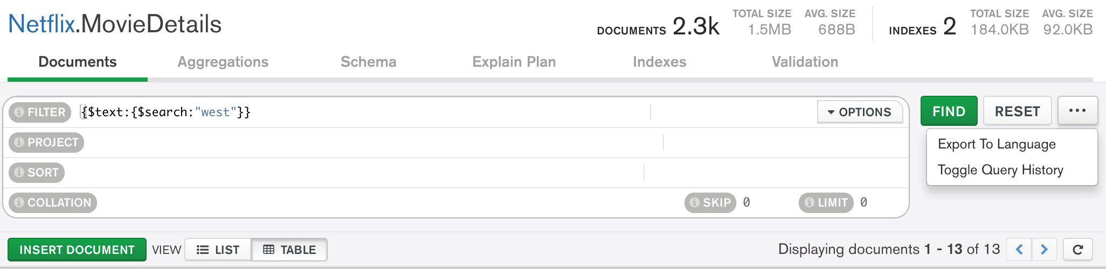

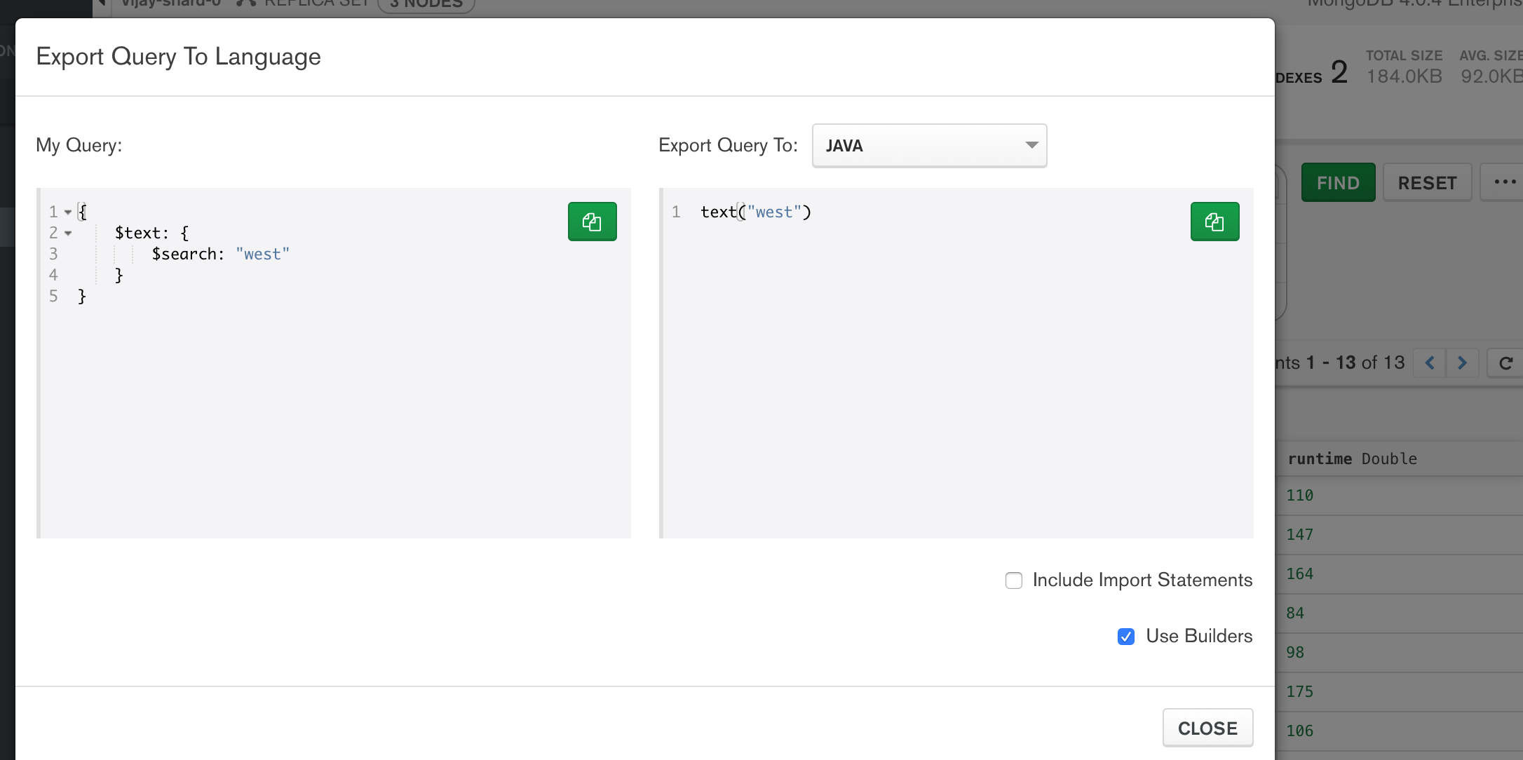

The Collection and query schema can be analyzed under schema tab.

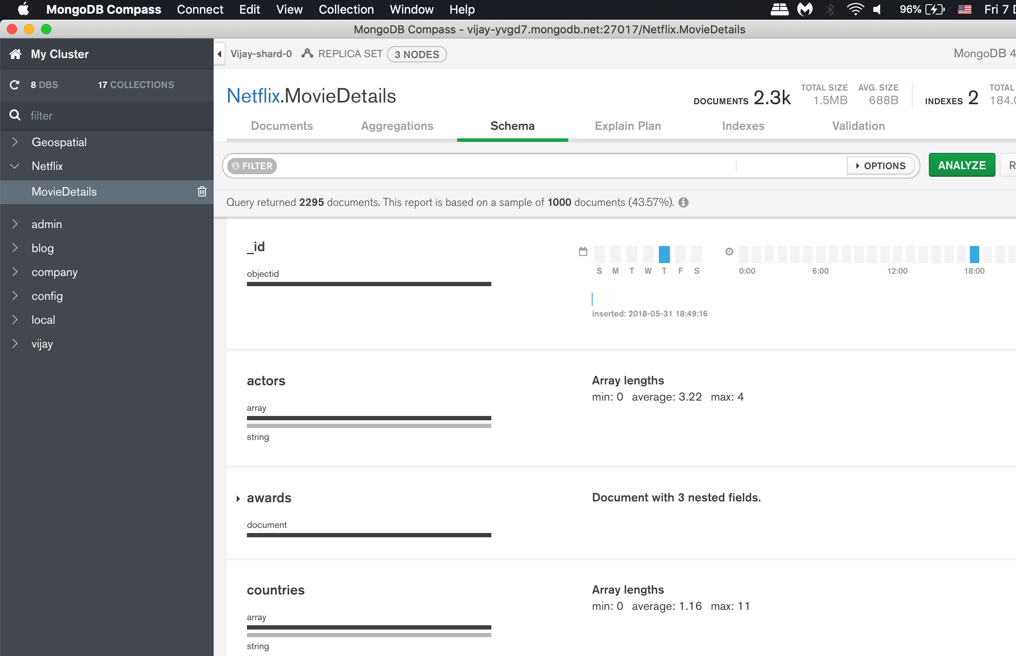

The Schema tab provides an overview of the data type and shape of the fields in a particular collection. Databases and collections can be viewed in the left-side navigation.

As MongoDB reports, “The schema overview is based on [sampling](https://docs.mongodb.com/compass/master/faq/#compass-faq-sampling) the documents in the collection. It can include additional data about the contents of the fields, like minimum and maximum values of dates and integers, the frequency of occurrence of particular values, and the cardinality of the data.

MongoDB has a flexible schema model, i.e. some fields may contain different types of data from one document to the next. For example, a field named address may contain strings and integers in some documents, objects in others, or some combination of all three. In the case of heterogeneous fields, the Schema tab shows a breakdown of the various data types contained within the field with the percentage of each data type represented. For each field, Compass displays summary information about the data type or types the field contains and the range of values.

Depending on the data type and the level of cardinality, Compass displays histograms, graded bars, geographical maps, and sample data to provide a sense of the shape and scope of the data contained in each field. For fields that contain multiple data types, Compass displays a percentage breakdown of the various data types across documents. If a collection contains documents in which not all fields contain a value, the missing values display as undefined. Fields that contain a sub-document or an array are displayed with a small triangle next to them and a visual representation of the data contained within the sub-document or array”. (MongoDB documentation, MongoDB Compass, Schema)

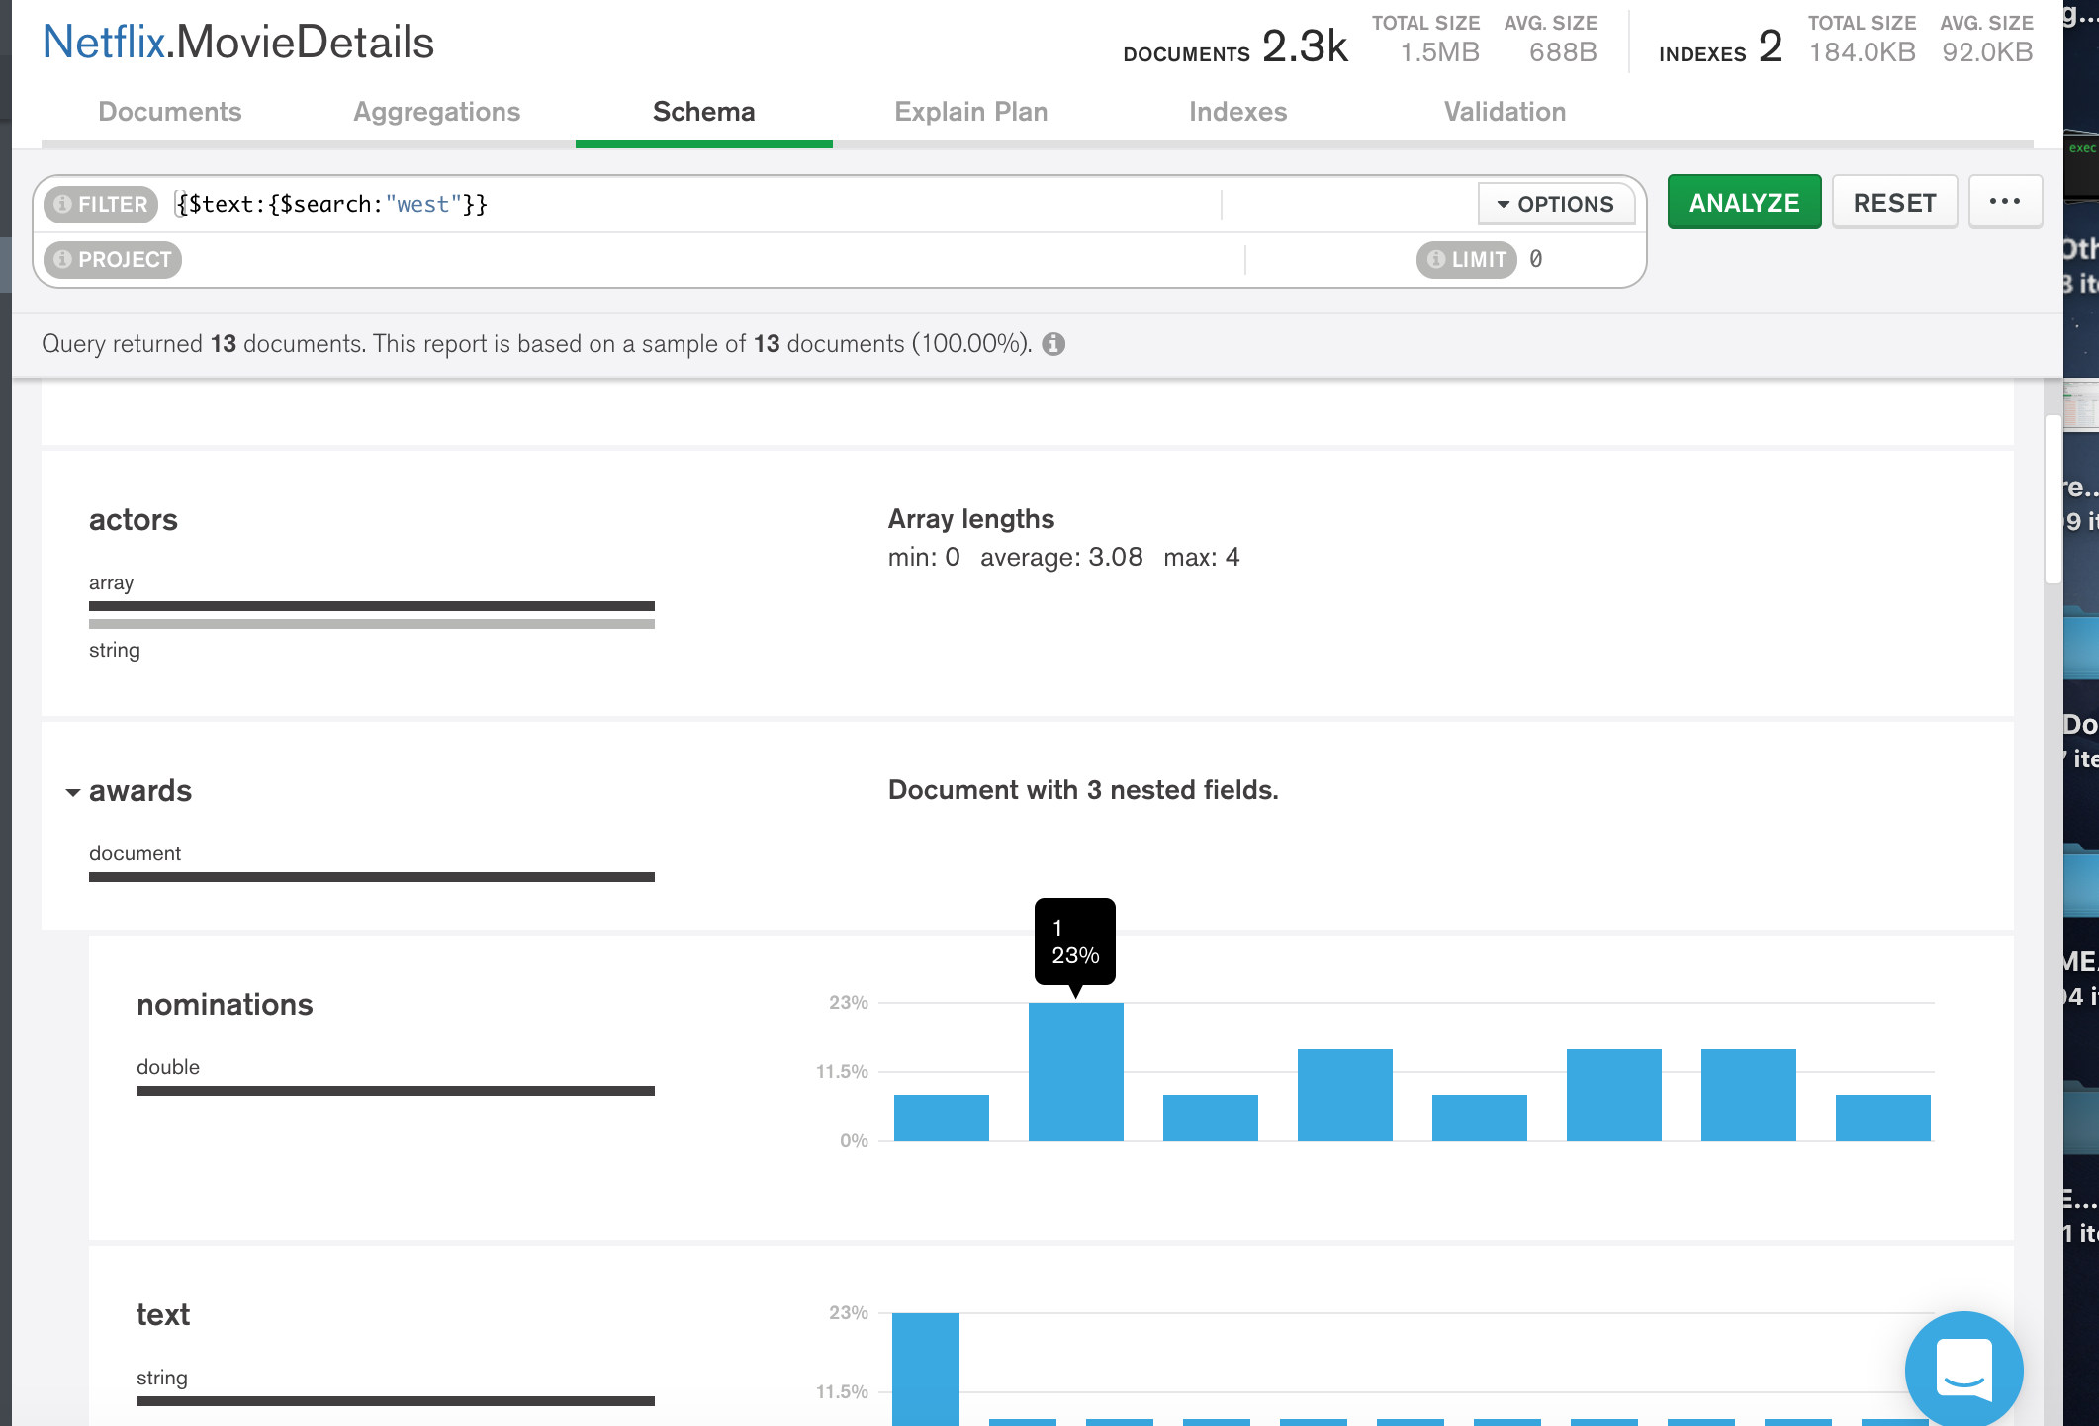

We can select the fields (highlighted as shown below) to build queries.

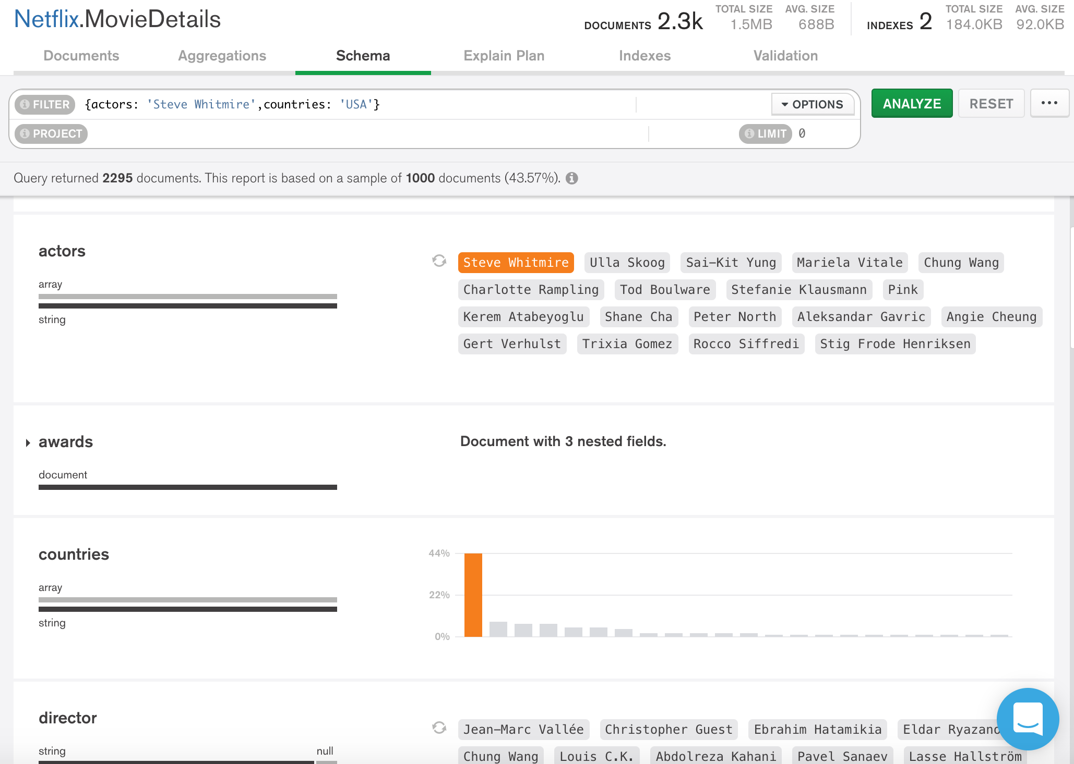

Fields which contain GeoJSON data ([latitude, longitude]) arrays can be visualized with interactive maps as shown below, we can build dynamic queries by pressing shift and dragging in the map.

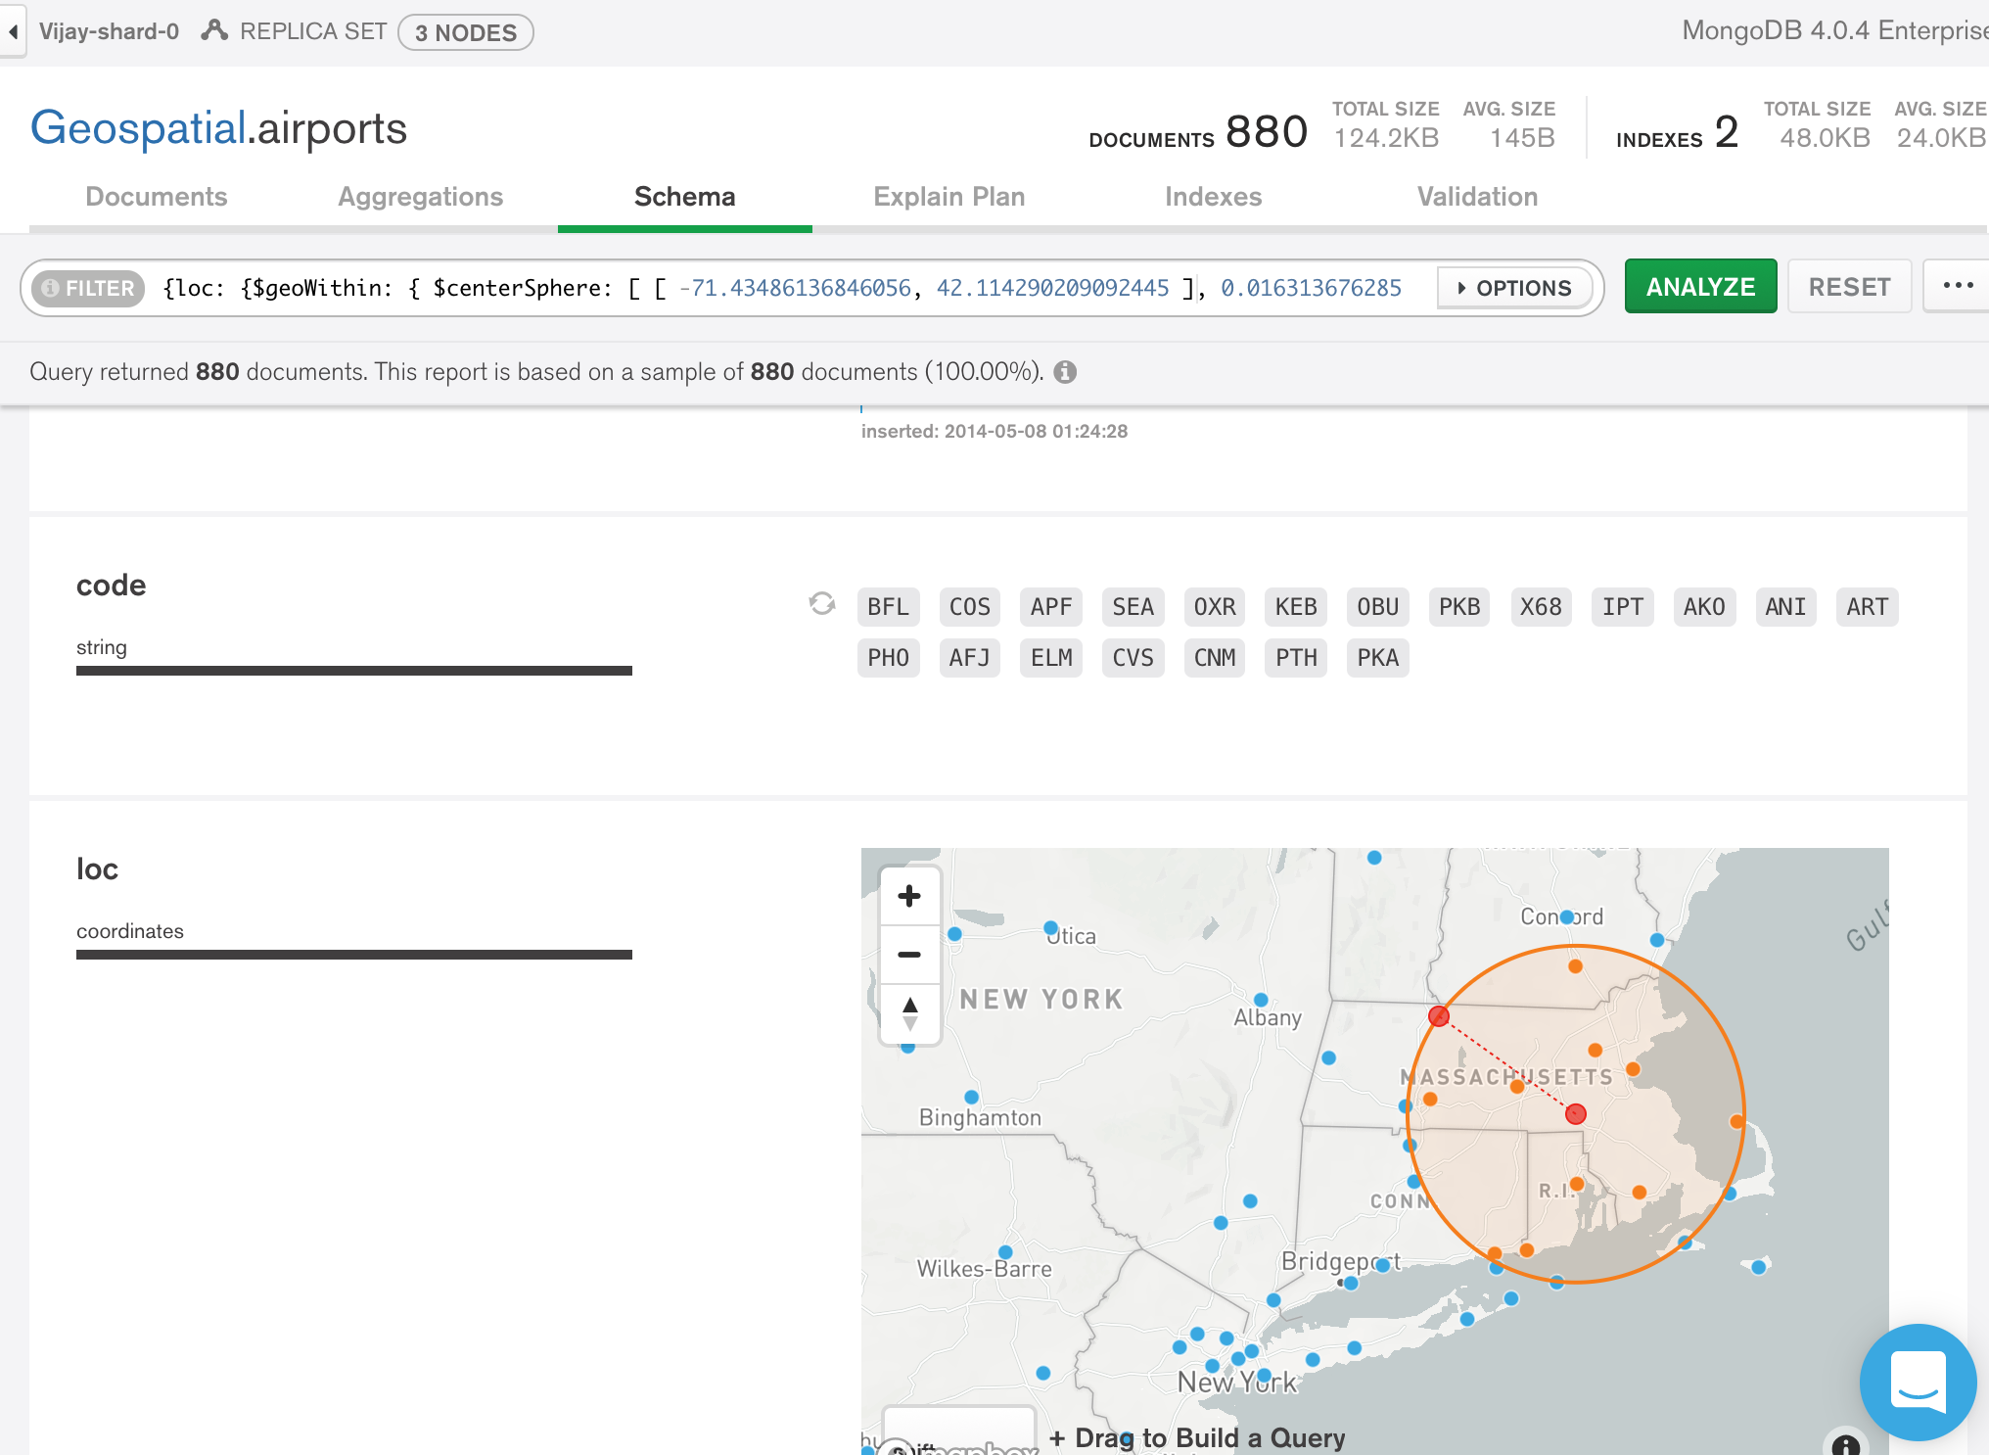

We can also analyze the query performance in the Explain Plan tab.

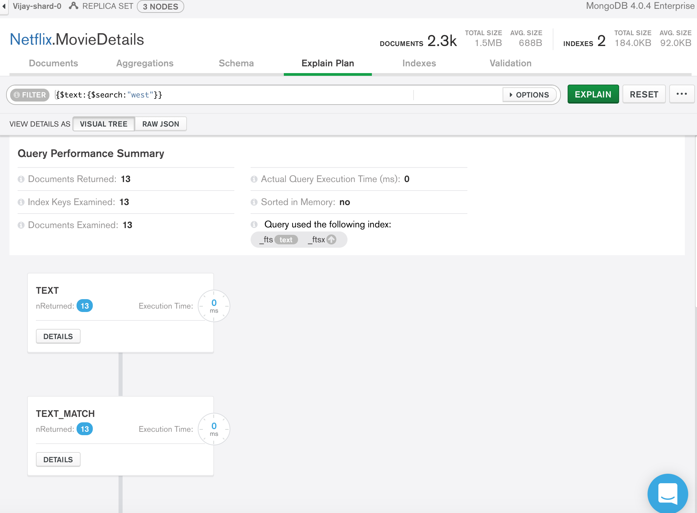

**Indexes** tab lists the existing indexes for a collection.

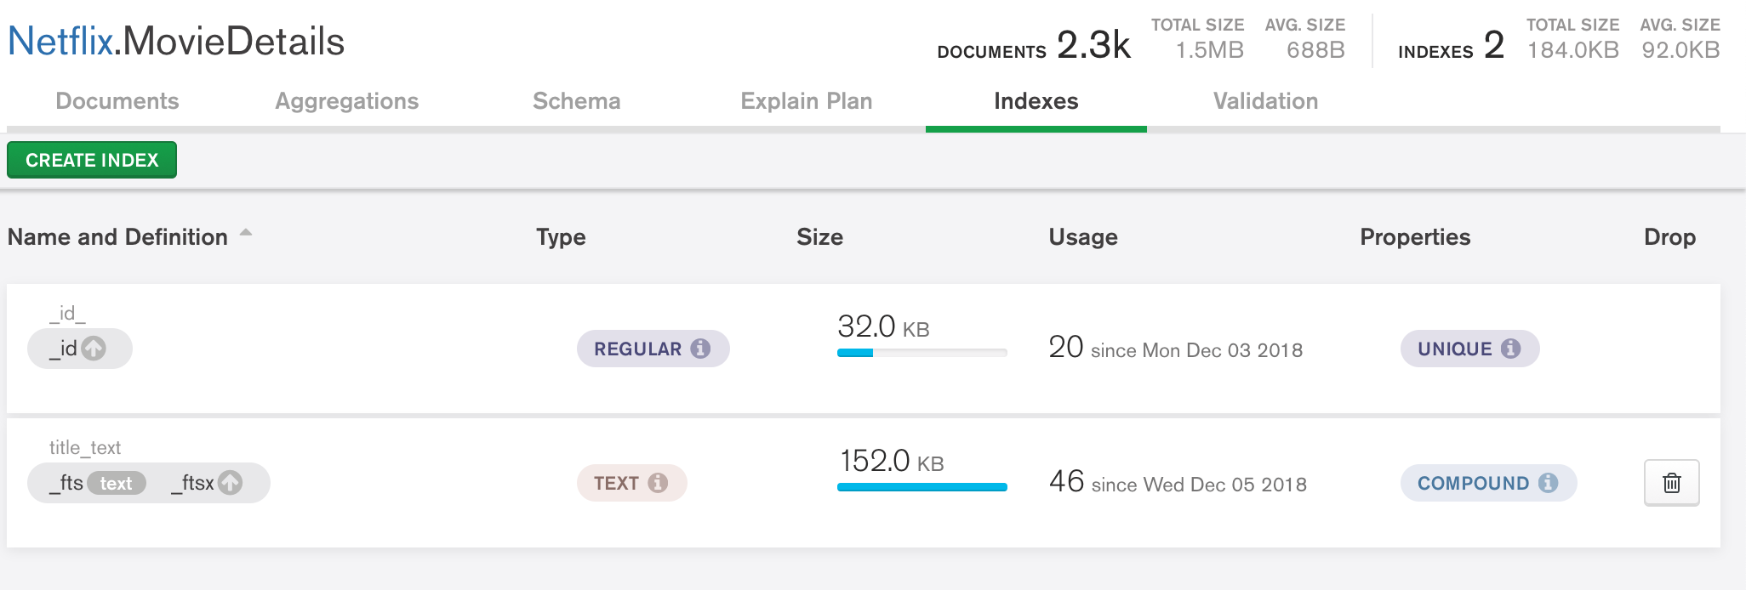

The **Validation** tab displays the schema validation specification (the validation rules, the validation level, and the validation action) that exists for a collection.

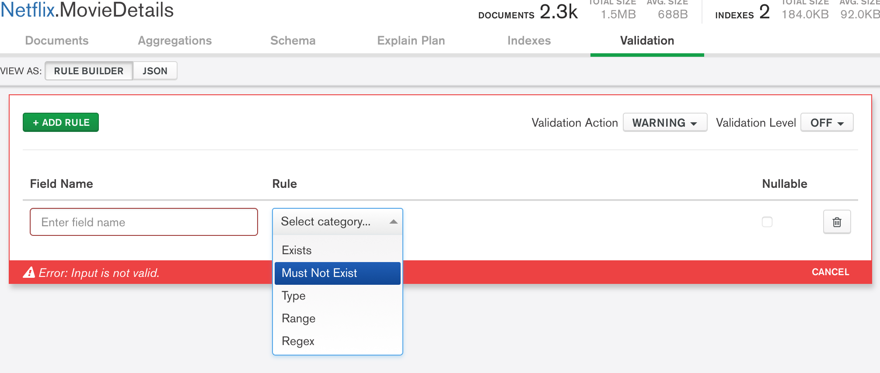

The below figure shows how aggregation tab. MongoDB Compass provides the ability to create aggregation pipelines to process data. With aggregation pipelines, documents in a collection pass through multiple stages where they are processed into a set of aggregated results. The particular stages and results can be modified depending on developer needs.

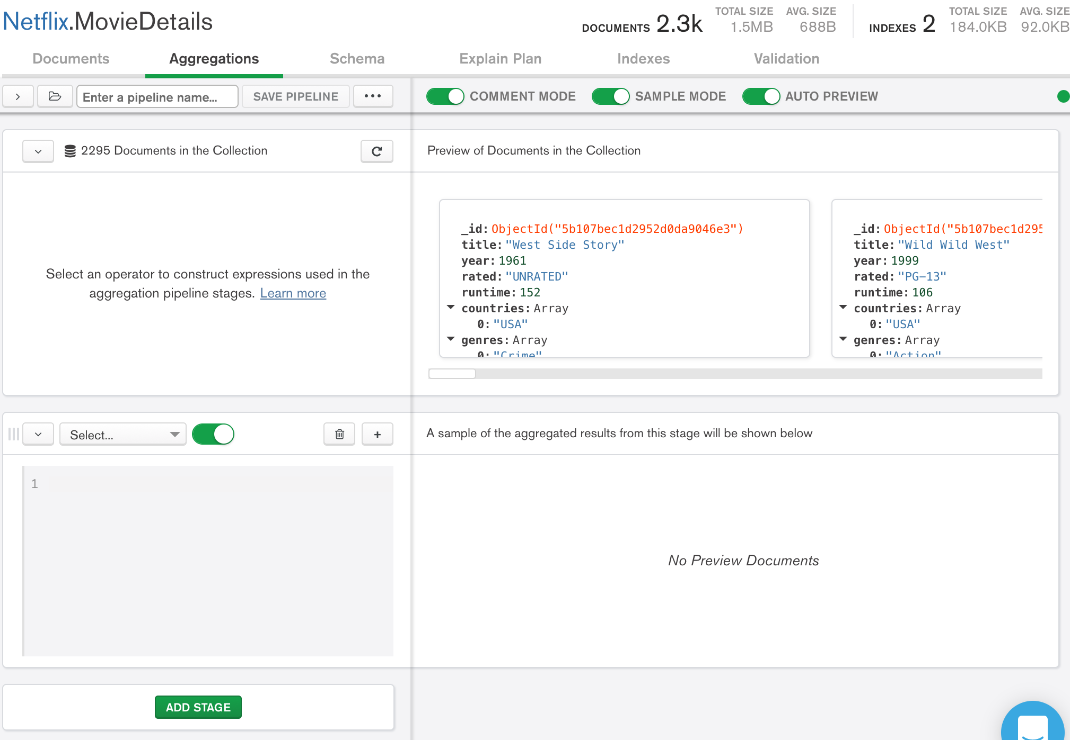

# 

# **MongoDB MapReduce**

As MongoDB cites, “Map-reduce is a data processing paradigm for condensing large volumes of data into useful aggregated results” (MongoDB manual, Aggregation, Map-Reduce). MongoDB uses MapReduce command for map-reduce operations. MapReduce is generally used for processing large data sets. Syntax: -

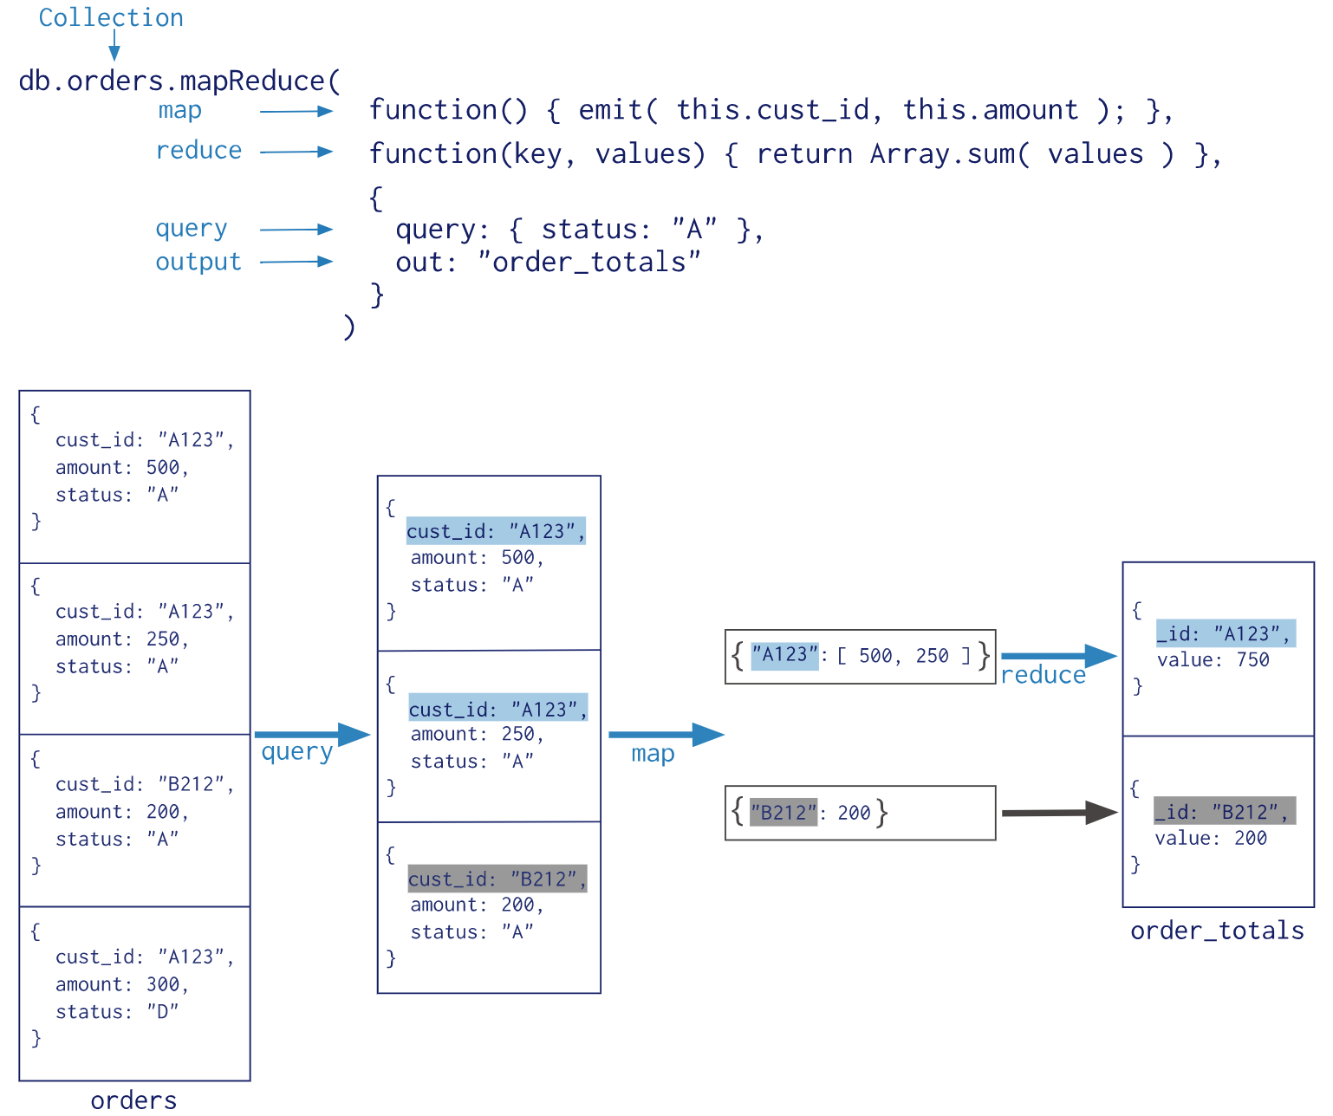

The above screenshot example is taken from MongoDB manual. (<https://docs.mongodb.com/manual/core/map-reduce/> )

* **map** is a JavaScript function that maps a value with a key and emits a key-value pair.
* **reduce** is a JavaScript function that reduces/groups all the documents having the same key.
* **out** specifies the location output of the map-reduce query result.
* **query** specifies the optional selection criteria for selecting documents.
* **sort** specifies the sort criteria.
* **limit** specifies the maximum number of documents to be returned.

**Implementation: -**

Consider below Author Collection

db.getCollection("author").find({});

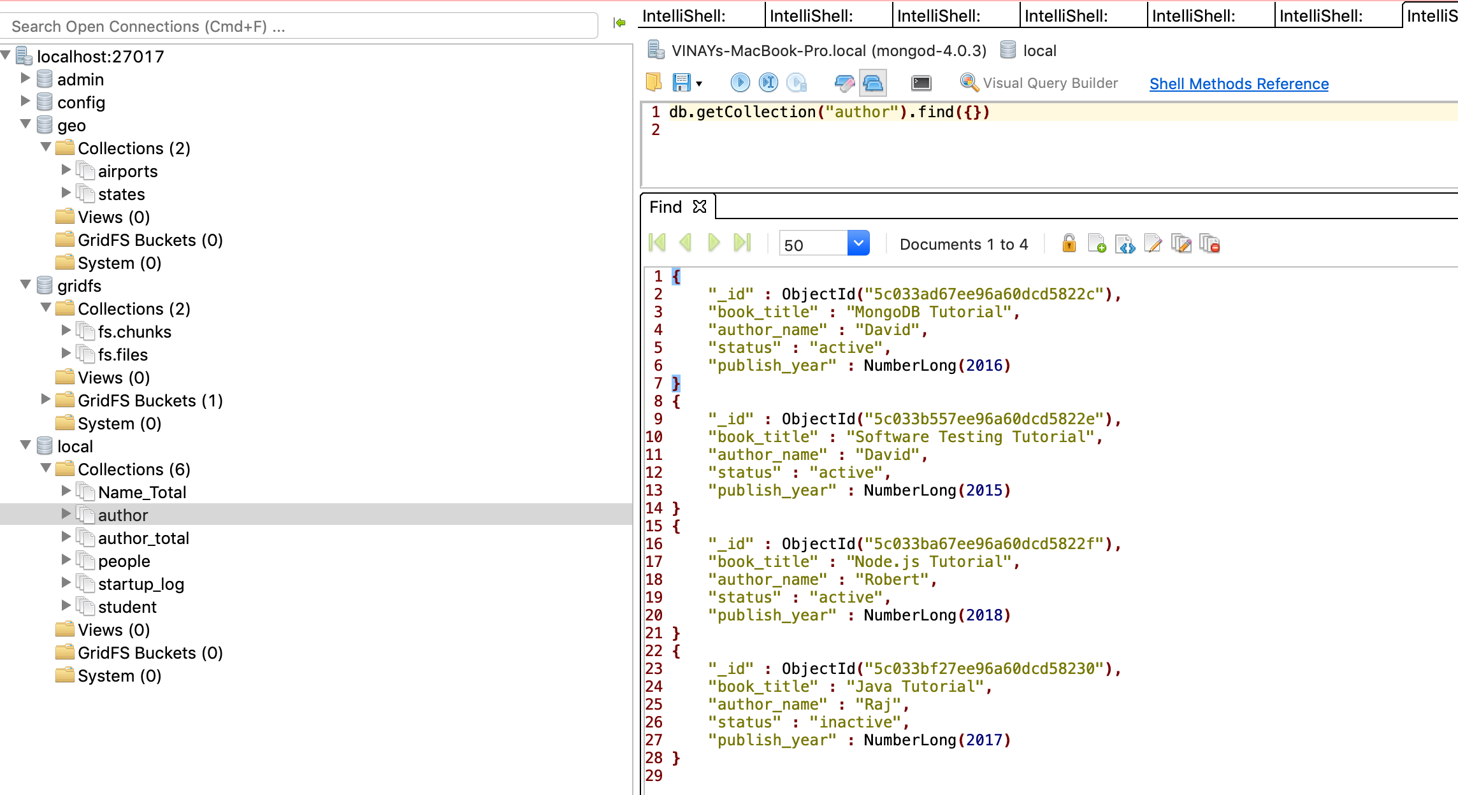

As shown above, the author collection has 4 documents having fields as _id, author name, book_title, status and publish_year..

**MapReduce function:**

The below function selects all the author names based on status.

db.author.mapReduce**(**

function**()** **{** emit**(**this.author_name**,**1**)** **},**

function**(**key**,** values**)** **{**return Array.sum**(**values**)},**

**{** query**:{**status**:**"active"**},** out**:**"author_total" **}** **);**

**Output: -**

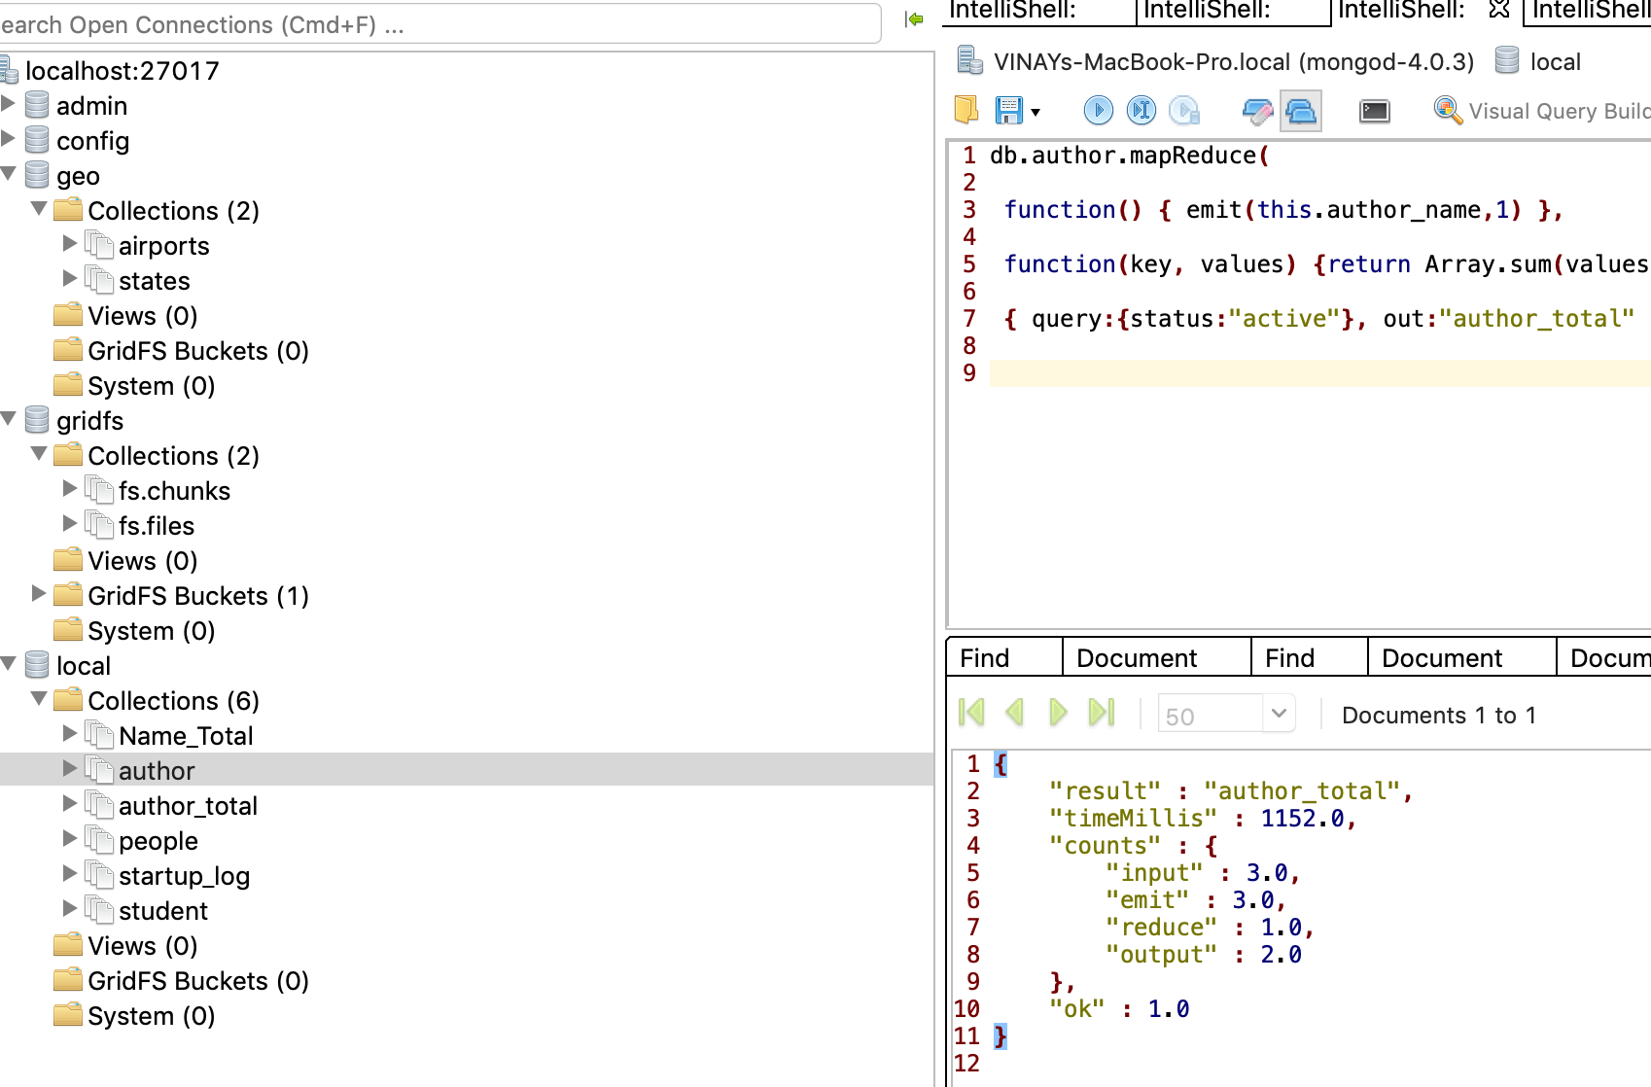

The above result shows MapReduce output as shown above, the reducer output is written into another collection called author_total.

Finding elements:

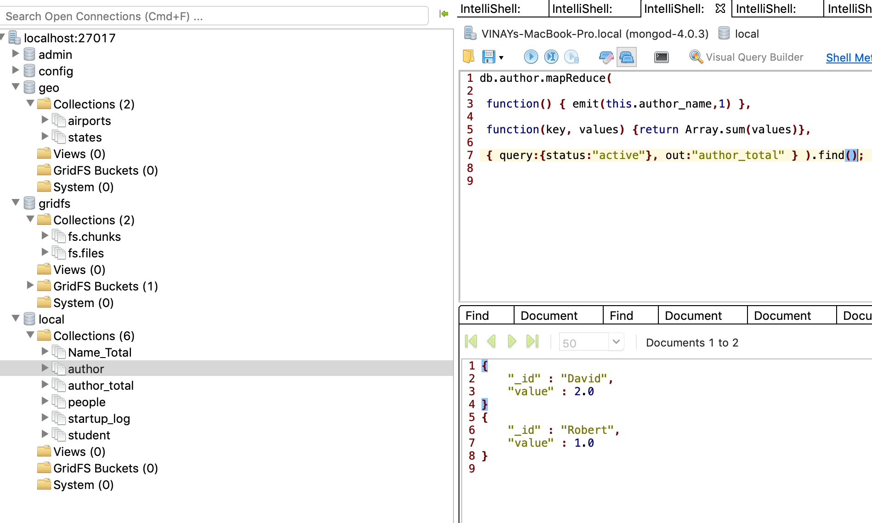

By adding find() function at the end of MapReduce function will show the result of the output.

# **GEOSPATIAL QUERIES**

MongoDB supports query operations on geospatial data.

**Geospatial Data**

In MongoDB, geospatial data can be stored as GeoJSON objects or as coordinate pairs.

**GeoJSON Objects**

GeoJSON is a format for encoding in JSON, a variety of geographic data structures, and support the following types: Point, LineString, Polygon , MultiPoint , MultiLineString , MultiPolygon and Geometry. In order to calculate geometry over an Earth-like sphere, location data are stored as GeoJSON objects.

GeoJSON document contains:

* a field named **type** that specifies the GeoJSON object type and
* a field named **coordinates** that specifies the object’s coordinates.
* Coordinates are stored in longitude (-180 to 180) and latitude (-90 to 90) order.

Examples: - (with different types)

{ "type": "**Point**",  
 "coordinates": [  
 -2.5,   
 48.5 ] }

{  
 "type": "**LineString**",  
 "coordinates": [  
 [-2.582,48.5955],  
 [-2.59,48.593],  
 [-2.550,48.592],  
 [-2.500,48.592],  
 [-2.5577, 48.58]  
 ]  
}

"type" : "**GeometryCollection**",  
 "geometries" : [  
 {  
 "type" : "Polygon",  
 "coordinates" : [  
 [  
 [ -73.90, 40.8 ],  
 [ -73.98, 40.7 ],  
 [ -73.97, 40.78 ],  
 [ -73.94, 40.71 ],  
 [ -73.90, 40.83 ]  
 ]  
 ]  
 },  
 {  
 "type" : "**MultiLineString**",  
 "coordinates" : [  
 [ [ -73.943, 40.789 ], [ -73.982, 40.795 ] ],  
 [ [ -73.915, 40.729 ], [ -73.954, 40.754 ] ],  
 [ [ -73.962, 40.785 ], [ -73.964, 40.775 ] ],  
 [ [ -73.970, 40.777 ], [ -73.976, 40.761 ] ]  
 ]  
 }  
 ]  
}

Below are the functions that can be used to work with Geospatial queries are:

* $geoIntersects - Used to determine the user’s current neighborhood.
* $geoWithin - To display the number of places covering a region.
* $nearSphere - To find places within a specified distance of the user from near to far in ascending order of distance.
* $centerSphere - This function is a MongoDB-specific syntax to denote a circular region.

**Implementation with example**:

I have taken 2 collections:

Airports: - Collection with the list of US airports (type - Point).

The GeoJson contains type as Point which has longitude and latitude as coordinates storing location of each airport.

Visualizing data:

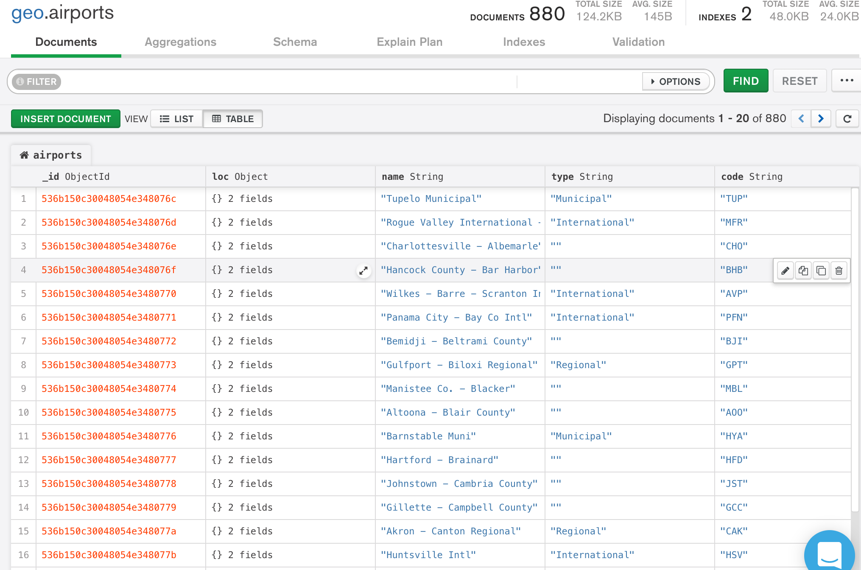

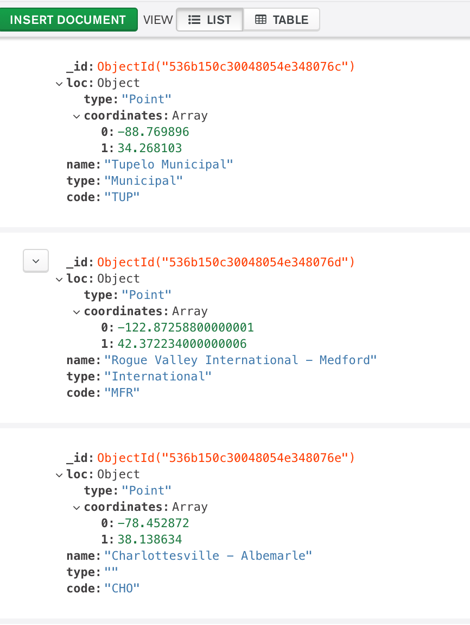

States: - Collection with the list of US states (Multi-Polygon).

This data contains type as **Polygon** and **Multi-polygon** which has list of longitude and latitude as coordinates storing the entire boundary region of each states.

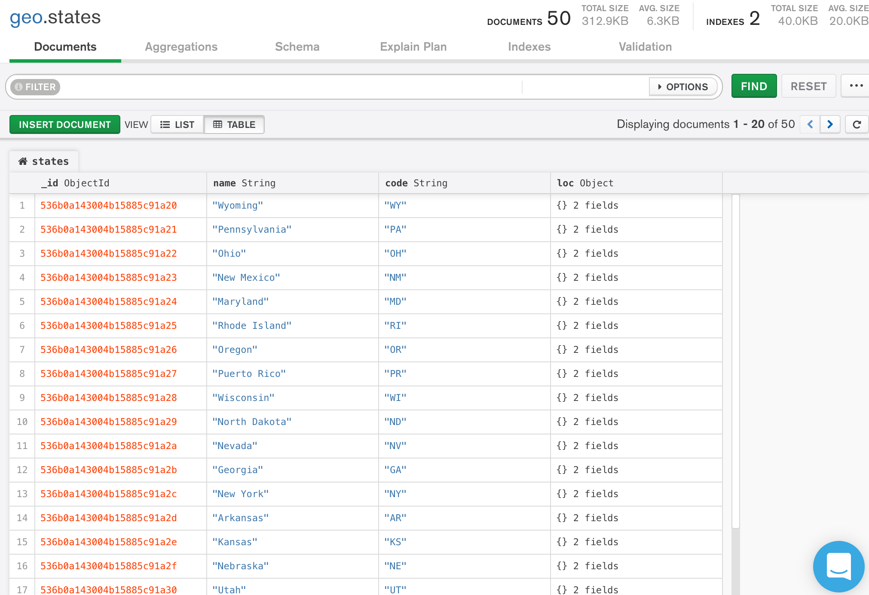

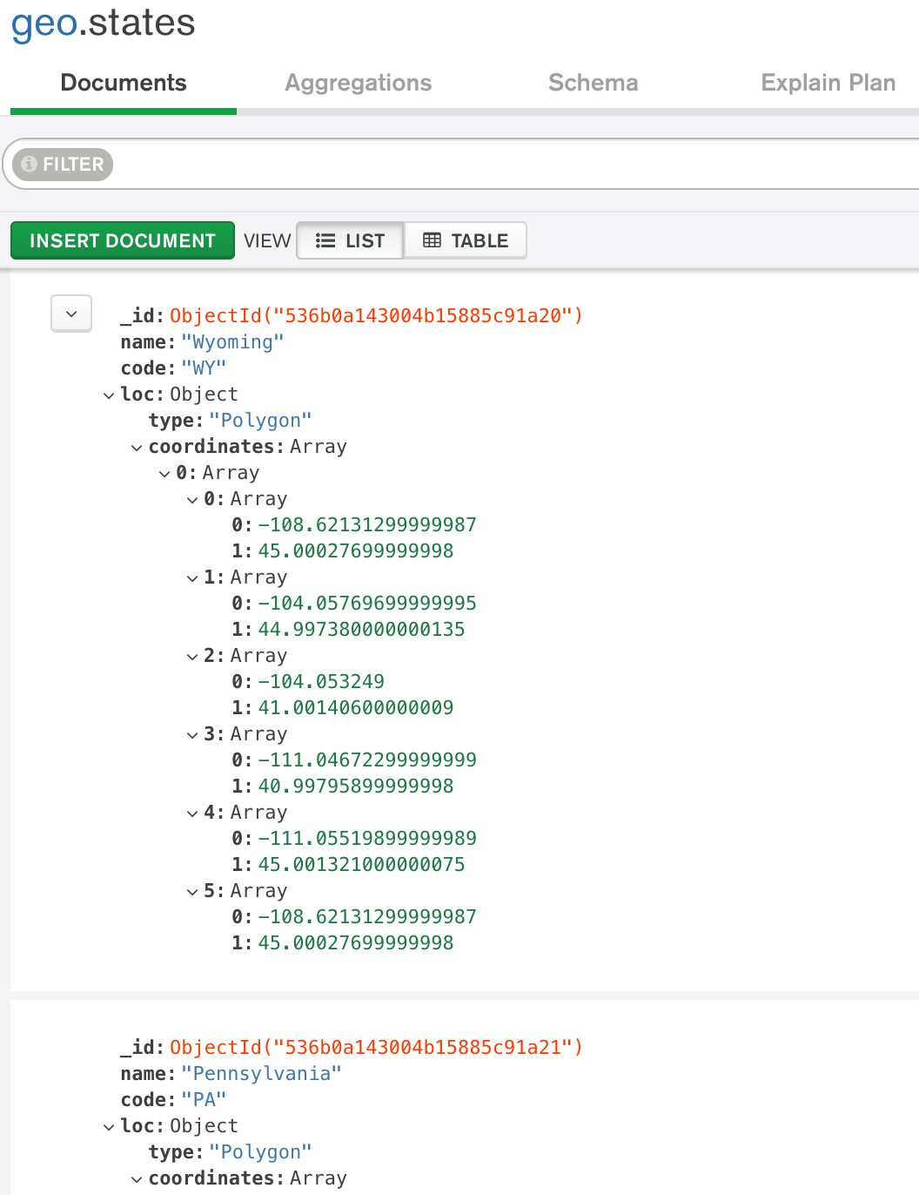

1. To find all airports covered in a specified region, for example to find all the airports present the state Massachusetts (MA).

**Query: -**

use geo;

var mas = db.states.findOne( {code : "MA"} );  
db.airports.find(   
 {   
 loc : { $geoWithin : { $geometry : mas.loc } }   
 },  
 { name : 1 , type : 1, code : 1, _id: 0 }   
);

* Switch to the database.
* Getting the boundary region of the state in a geometry (in this case polygon) into a variable *mas*.
* The function ***$geowithin*** is used to get all the airports within the specified state MA.

The query returned 11 documents with all the airports present in the state **Massachusetts**.

**Result: -**

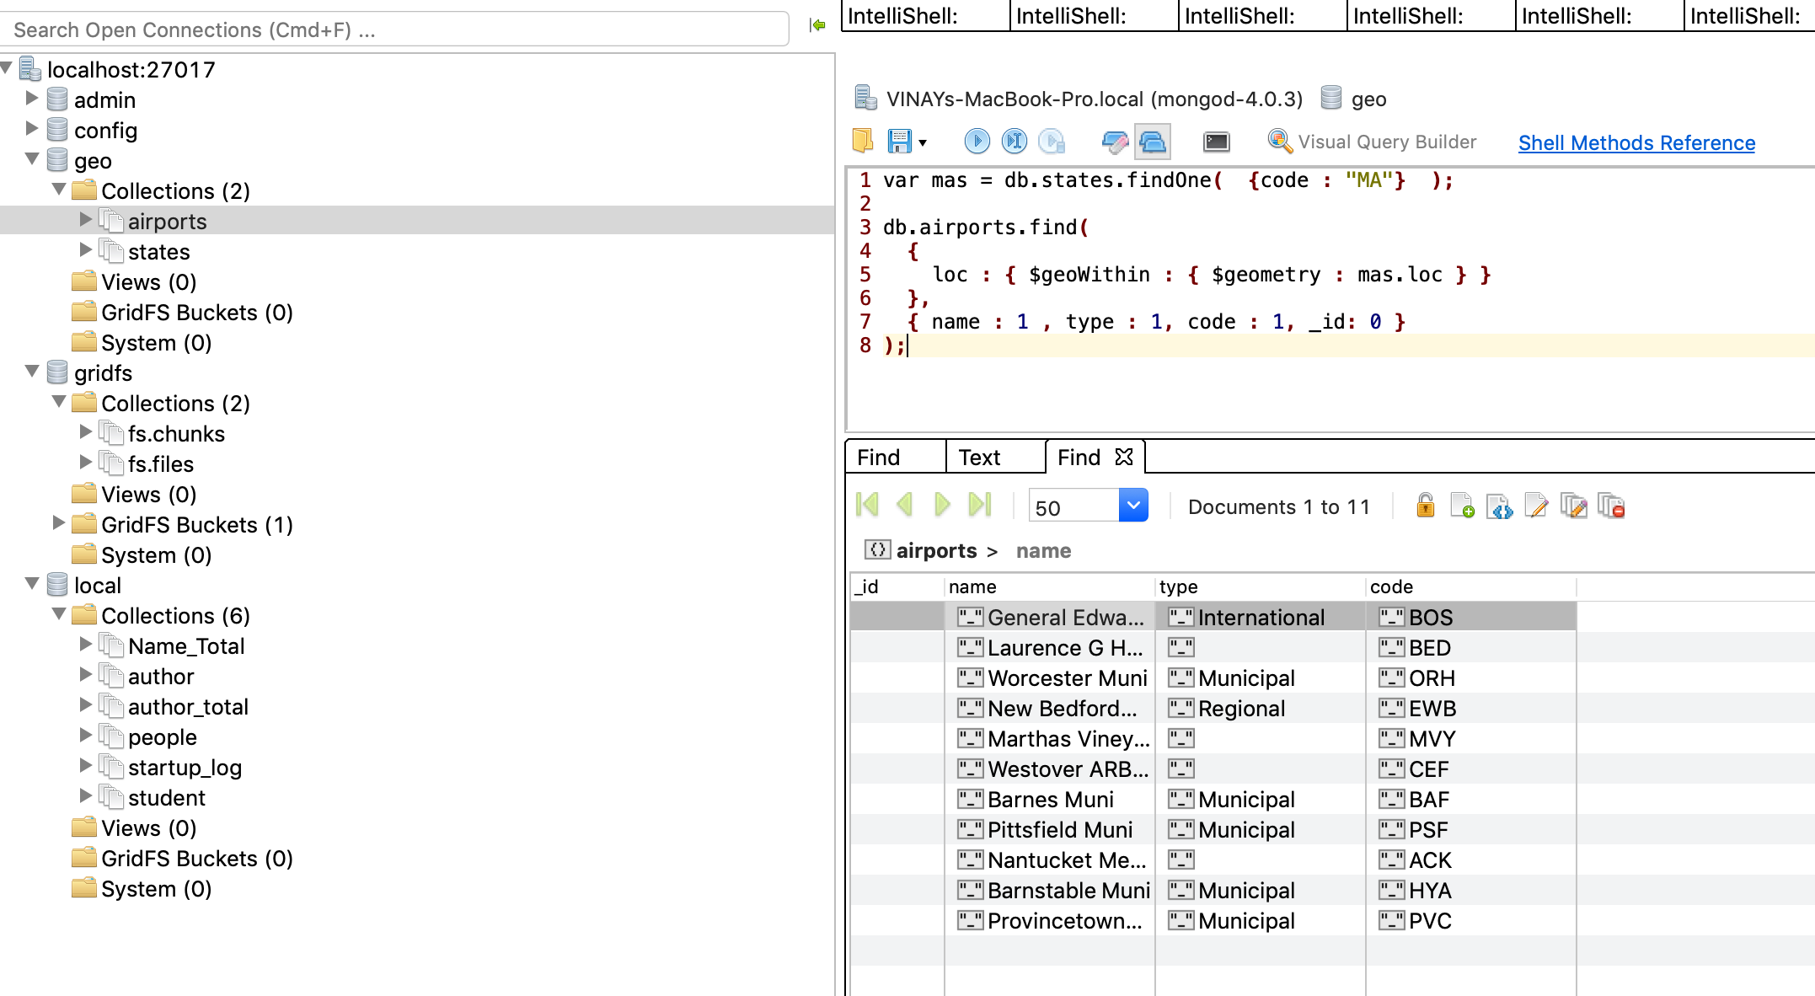

In order to improve query performance, we can create index, example:

db.airports.ensureIndex( { "loc" : "2dsphere" } );

db.states.ensureIndex( { loc : "2dsphere" } );

2. If we want to know what are all the adjacent states to Massachusetts, we need to search for all the states that have coordinates that ‘intersects’ with Massachusetts and negate with current state.

**Query: -**

var mas = db.states.findOne**(** **{**code **:** "MA"**}** **);**

db.states.find**( {**

loc **:** **{** $geoIntersects **:** **{** $geometry **:** mas.loc **}** **},**

code **:** **{** $ne **:** "MA" **}** **},**

**{** name **:** 1**,** code **:** 1 **,** _id **:** 0 **}** **);**

**Result: -**

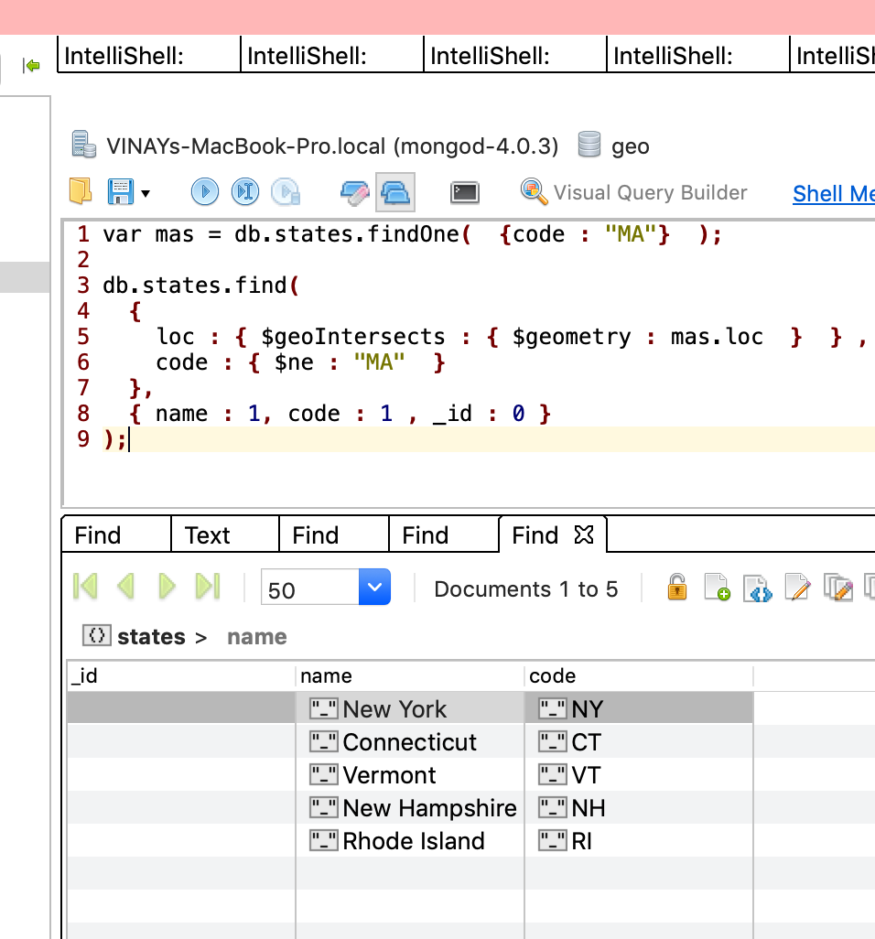

3. If we want to find all the international airports that are located at less than 20km from the reservoir in NYC Central Park. We can use the $near operator.

**Query: -**

db.airports.find**( {** loc **:** **{**

$near **:** **{** $geometry **:** **{** type **:** "Point" **,**

coordinates **:** **[**-73.965355**,**40.782865**]** **},**

$maxDistance **:** 20000 **}** **},** type **:** "International" **},**

**{** name **:** 1**,** code **:** 1**,** _id **:** 0 **} );**

**Result: -**

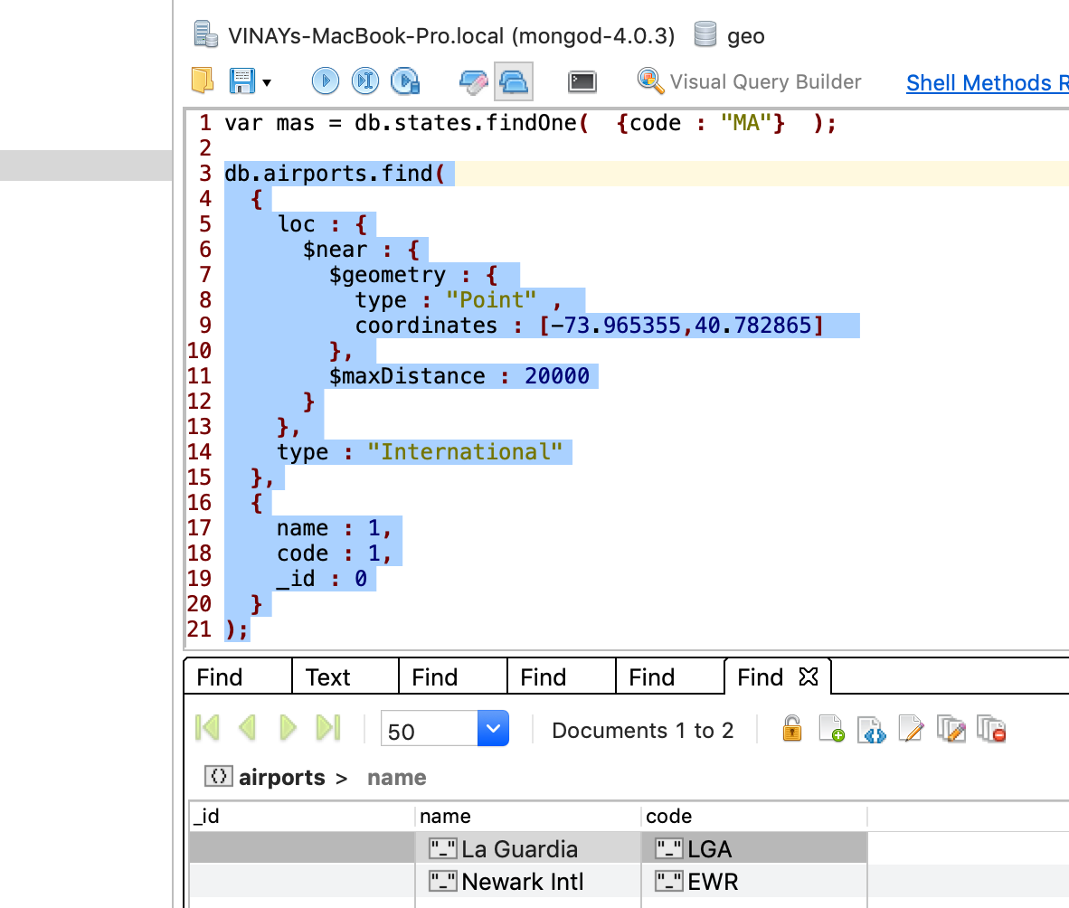

# **MongoDB STITCH**

MongoDB Stitch is a Backend as a Service that allows easily configure authentication, data access rules, and services.

As MongoDB reports, “Stitch is a serverless platform makes it easy to build modern, cross-platform applications on top of MongoDB. Stitch removes the need for tedious boilerplate and automatically manages your app’s backend so that developers can focus on building what matters” (MongoDB documentation, MongoDB Stitch).

**Features:**

* Stitch Query Anywhere:
  + This exposes the full power of working with documents in MongoDB and the MongoDB query language, directly from your web and mobile application frontend code. A powerful rules engine lets developers declare fine-grained security policies.
* Stitch Functions:
  + Allows developers to run simple JavaScript functions in the Stitch serverless platform, making it easy to implement application logic, securely integrate with cloud services and microservices, and build APIs.
* Stitch Triggers:
  + Developers can execute functions in real time in response to changes in the database or user authentication events.

There are 2 kinds of triggers that can be implemented with Stitch:

* + - Database trigger: - Allows execution of server-side logic whenever a document is added, updated, or removed in a linked MongoDB cluster.
    - Authentication Trigger: - Advanced user management, including storing new user data in MongoDB, maintaining data integrity when a user is deleted, or calling a service with a user’s information when they log in.
* Stitch Mobile Sync (Beta):
  + Allows automatic synchronization of data between documents held locally in MongoDB Mobile and the backend database.

(MongoDB, MongoDB Stitch, Ref: <https://www.mongodb.com/cloud/stitch> )

**Implementation:**

Created 2 MongoDB Stitch apps in MongoDB Atlas cloud cluster.

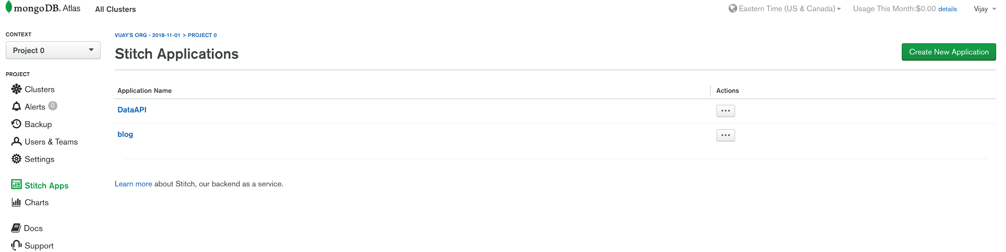

1. **Data API**:

This is an API that exposes data which can be used by various kind of applications. We can create several services in the stitch app and can select a service of any choice as shown below.

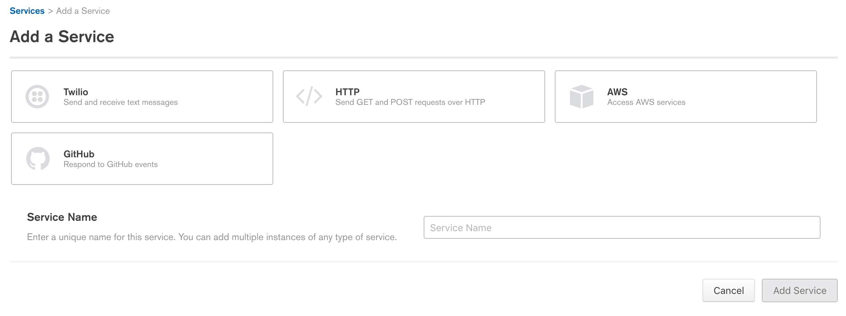

I have chosen **http** service and created 3 services as shown below.

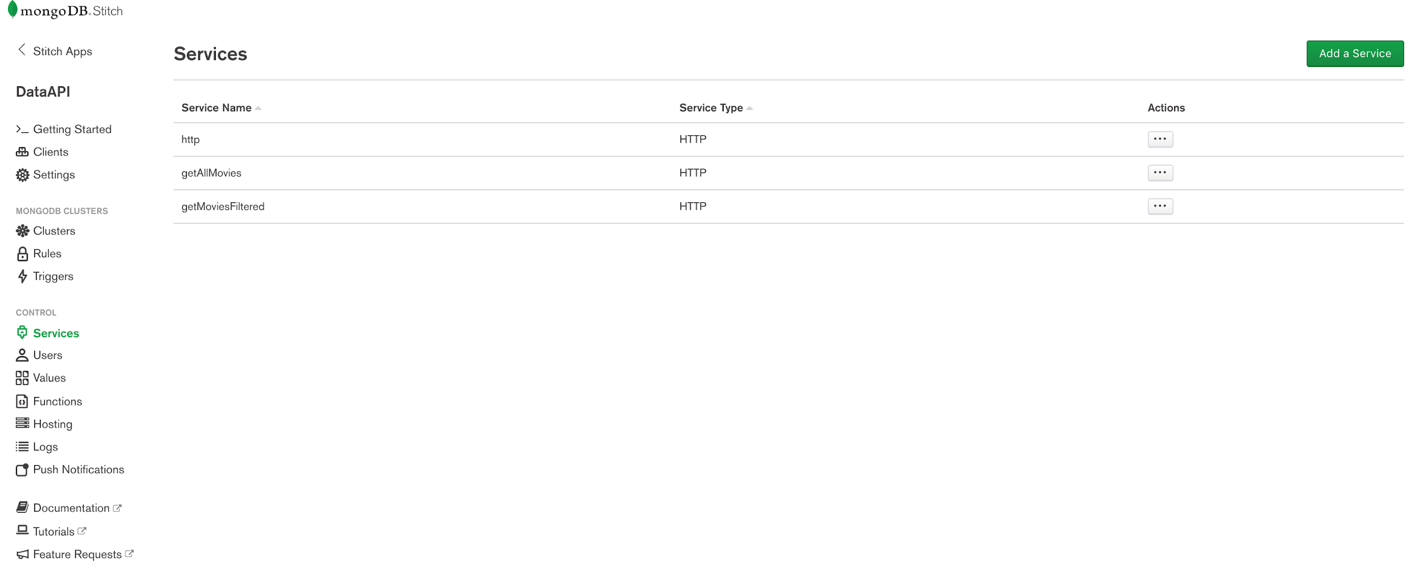

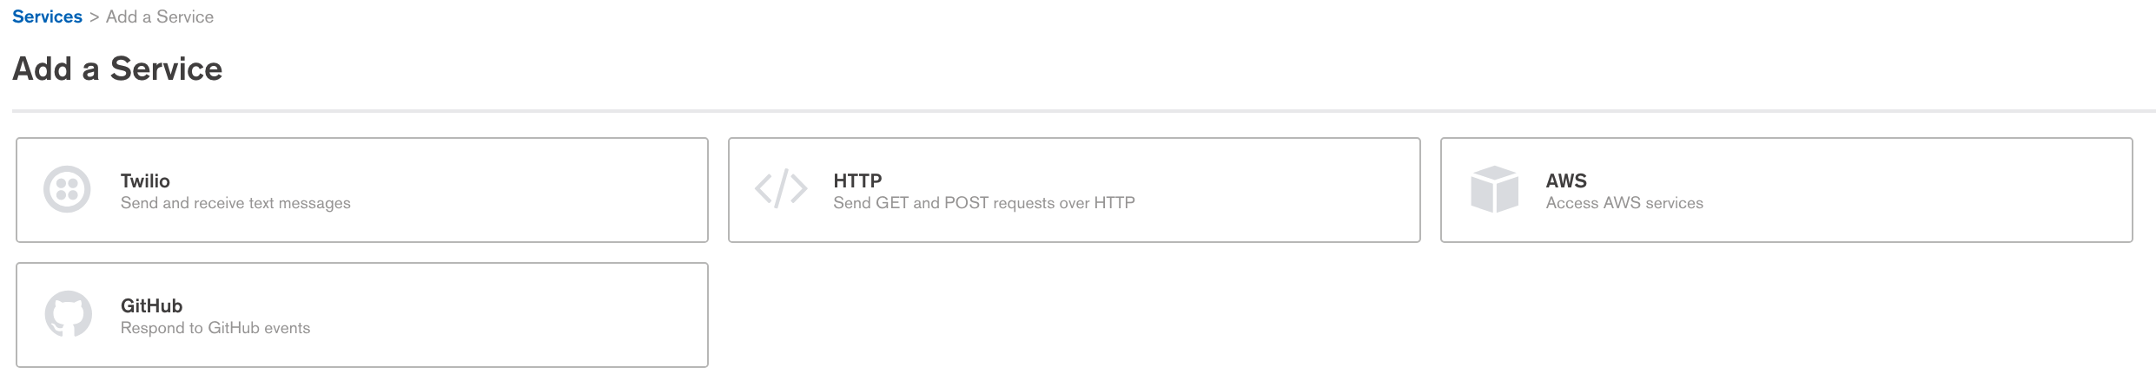

Then, a webhook is created with below settings based on requirements.

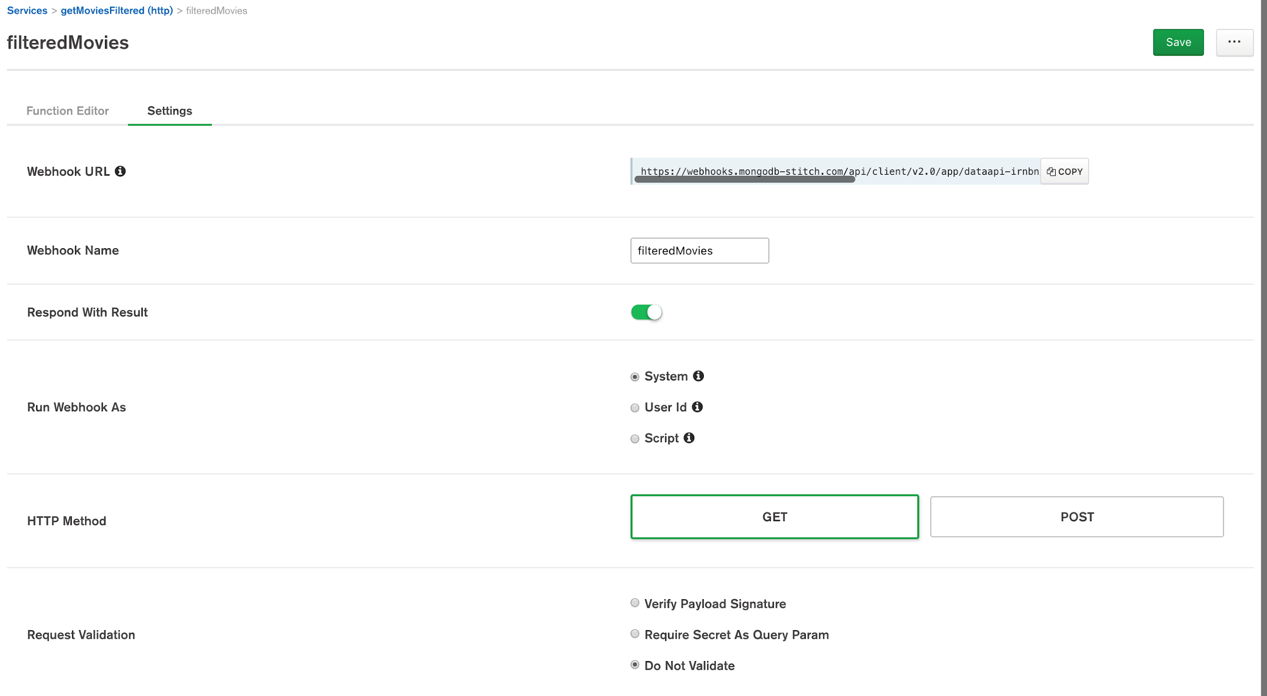

In the function editor, we can write a JavaScript function with mongo dB query to retrieve or store data from/into the database.

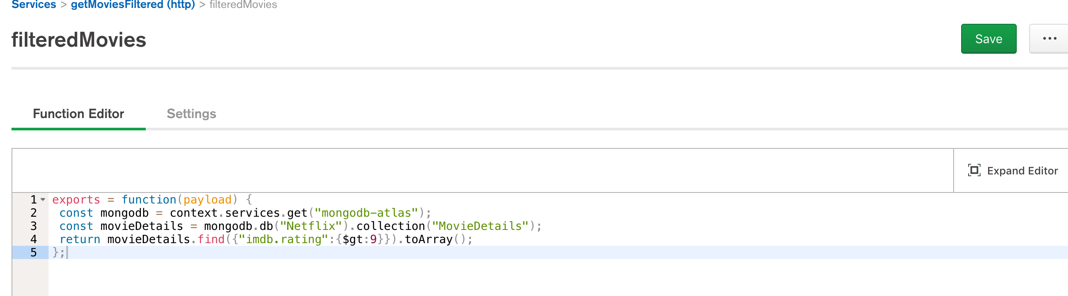

The above function returns all the movies from Netflix database with imdb rating greater than 9. Once the function is saved, we can access the API with an URL and test it in a tool like Postman or any browser.

Webhook Name: - filteredMovies

Webhook URL: - (The below URL does not need any authentication)

<https://webhooks.mongodb-stitch.com/api/client/v2.0/app/dataapi-irnbn/service/getMoviesFiltered/incoming_webhook/filteredMovies>

The above URL acts as an API to get the data from movieDetails collection.

Executed in Postman tool: -

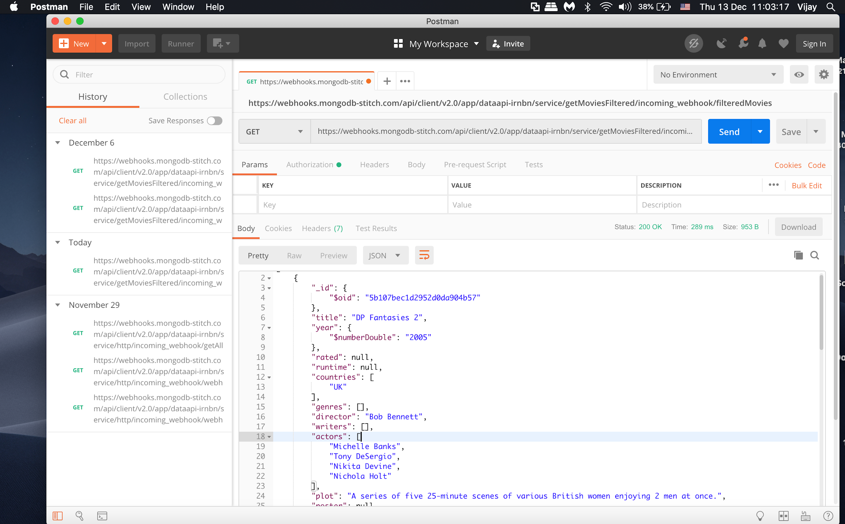

Executed in Chrome Browser: -

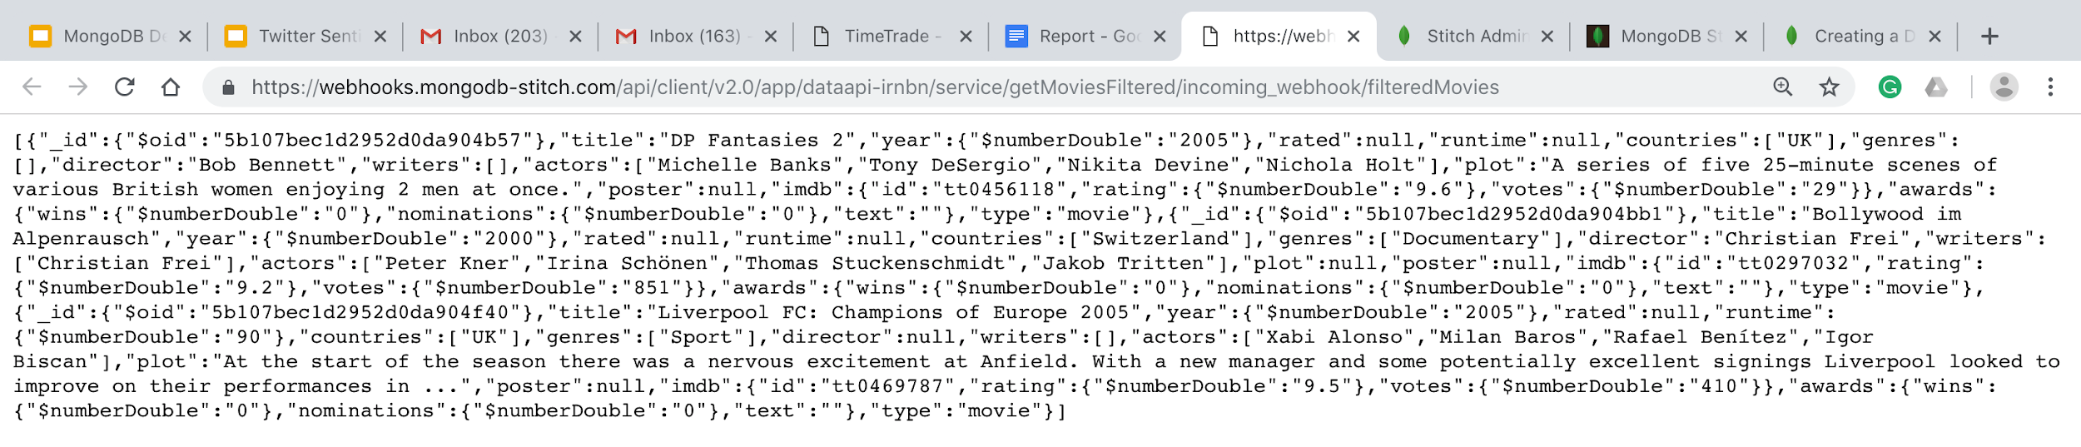

1. **Blog (HTML/JavaScript App)**:

This is another app written in JavaScript and HTML where anyone can post comments and the comments gets stored into database collection named ‘***comments’*** that I have created in the cloud.

Application: -

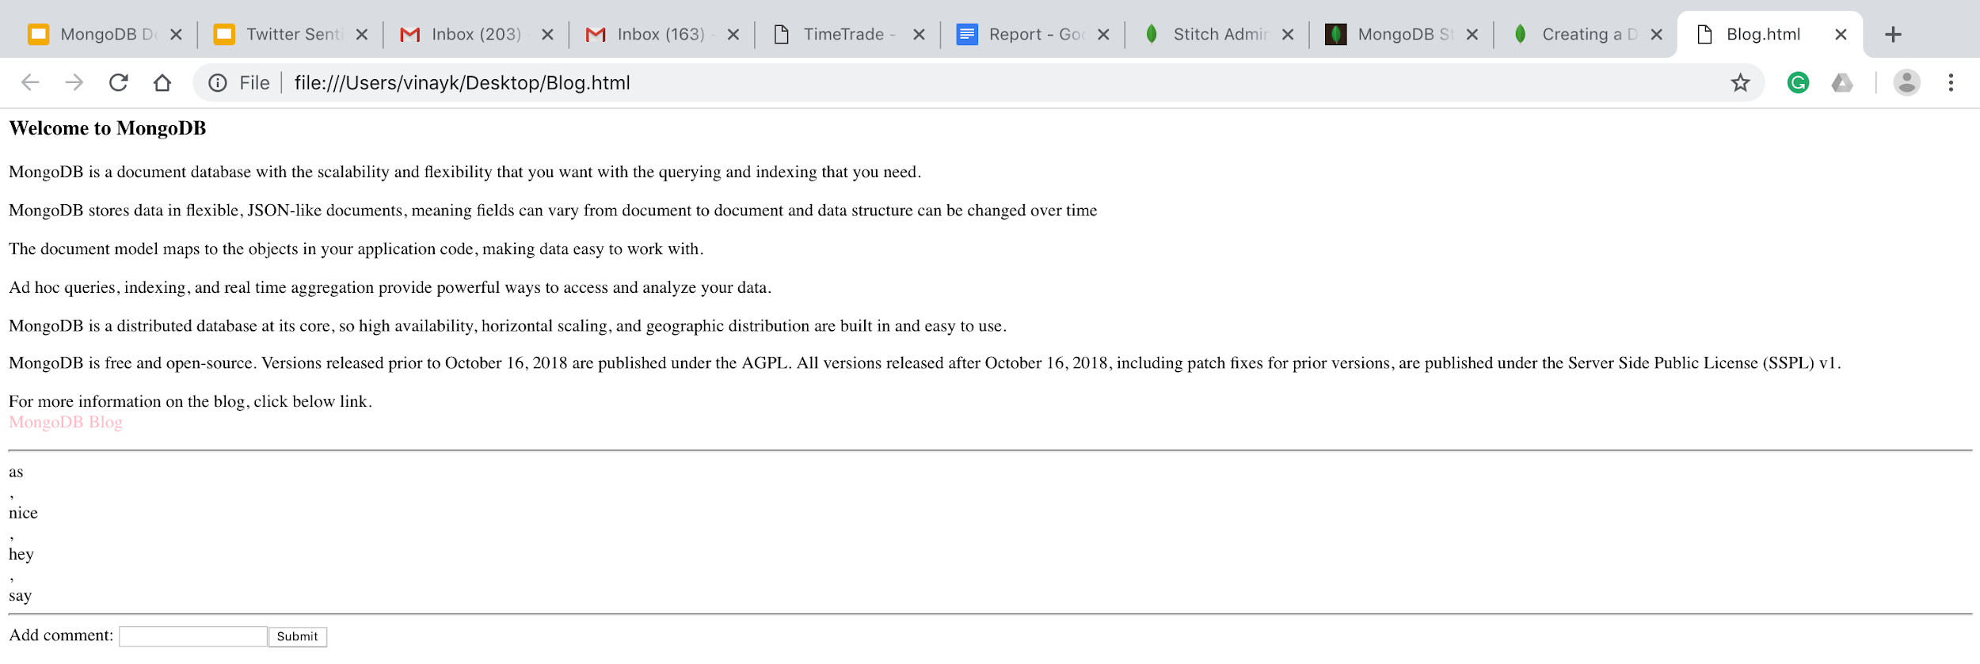

The above file is executed in a local machine and in the comment box, comments can be added that can be stored into the database.

Comments stored in database:

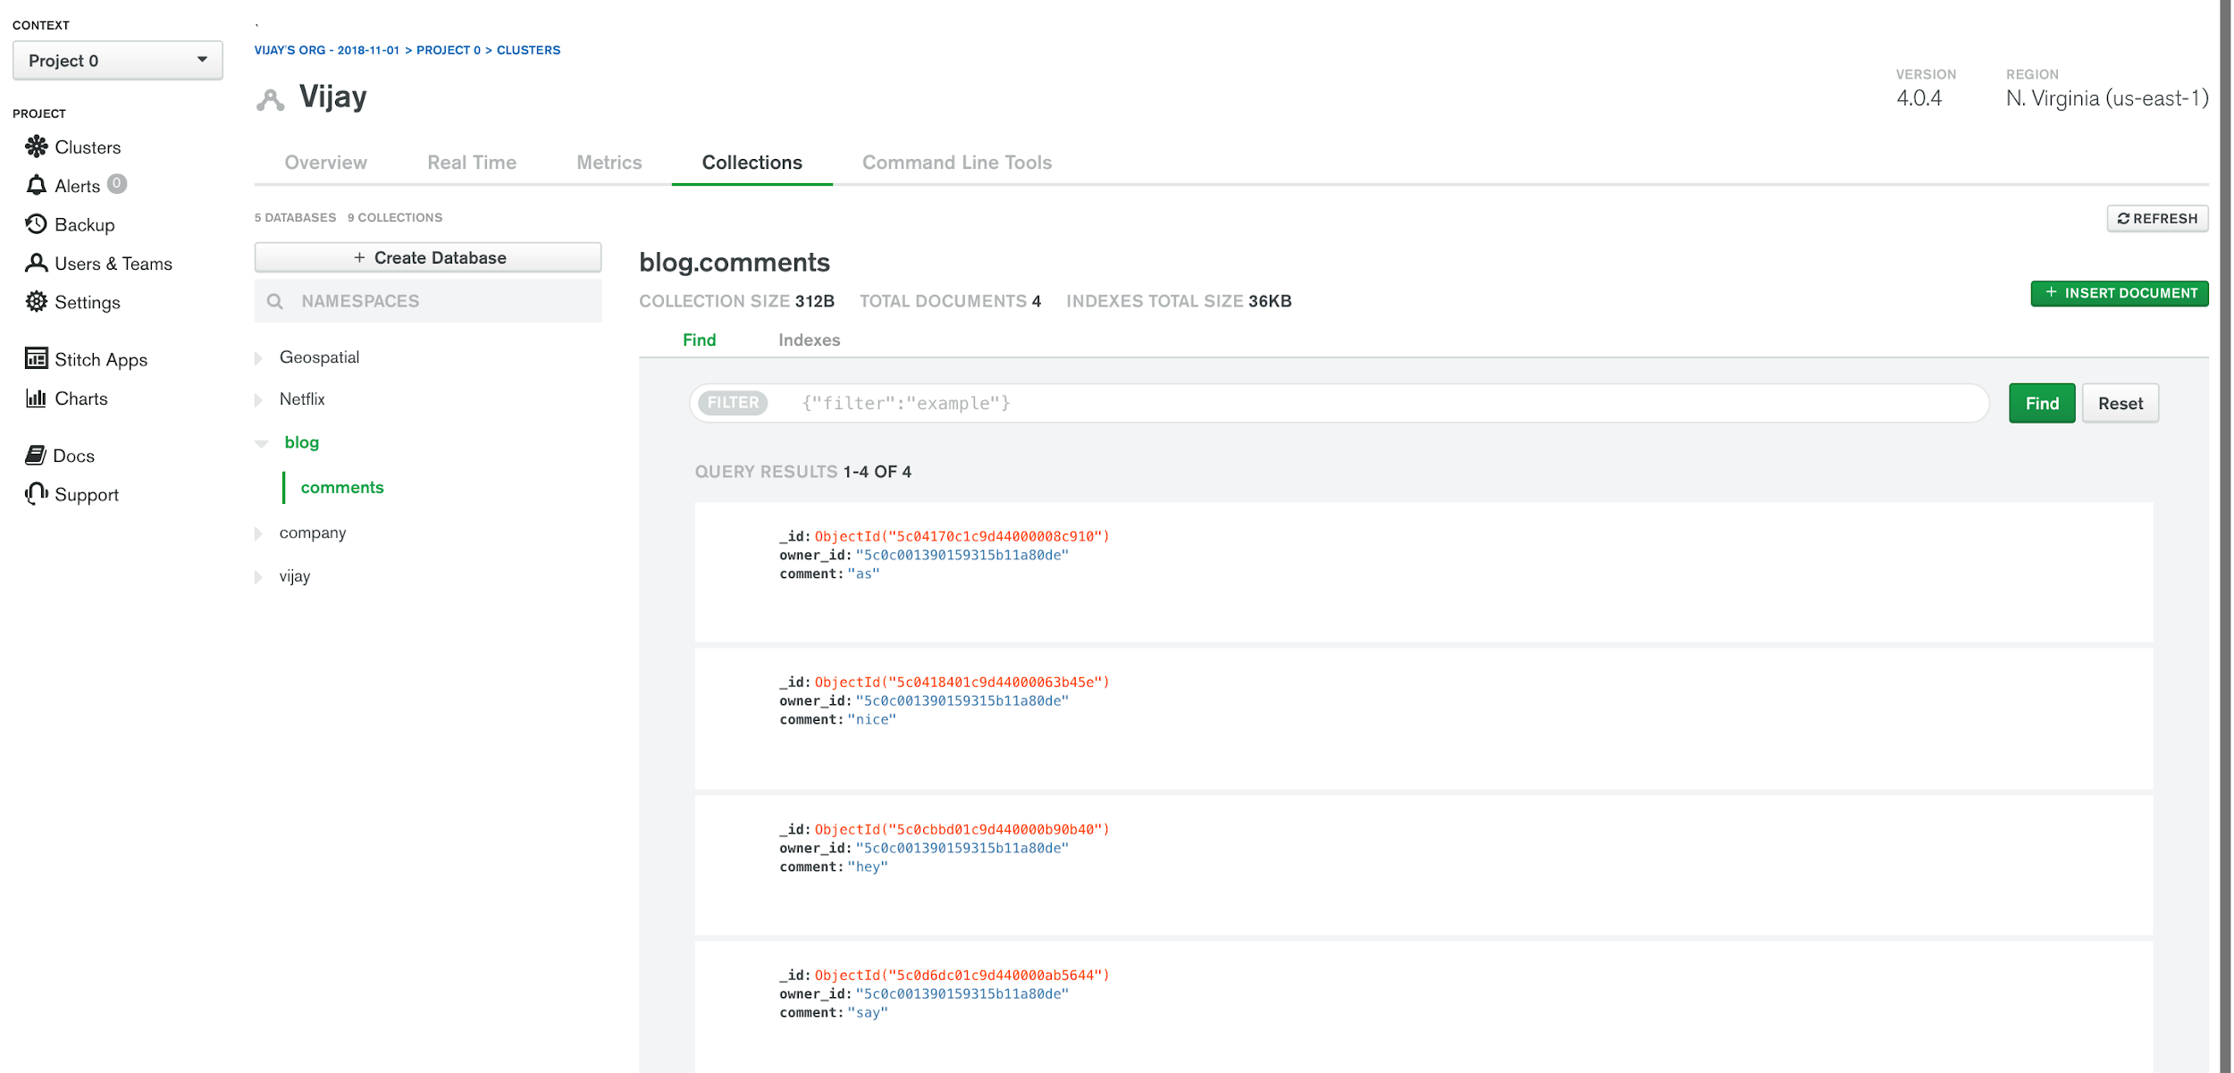

The source code is attached and the file can be opened in the browser and code can be seen by selecting ‘view page source’ in the browser.

# **MongoDB DRIVERS**

MongoDB offers drivers to connect to its database in almost all languages like C, C++, Java, Scala, Python, Ruby etc. where any application written in these languages can connect to MongoDB database written in their specific language.

Example: In Java, below maven dependency is added and database connection is made via few lines of code.

<dependency>  
 <groupId>org.mongodb</groupId>  
 <artifactId>mongodb-driver-sync</artifactId>  
 <version>3.9.1</version>  
 </dependency>

MongoClient mongoClient = new MongoClient("localhost", 27017);

Mongo mongo = new Mongo("localhost", 27017);

DB database = mongoClient.getDB("myMongoDb");

boolean auth = database.authenticate("username", "pwd".toCharArray());

DBCollection collection = database.getCollection("customers");

BasicDBObject document = new BasicDBObject();

document.put("name", "Vijay");

collection.insert(document);

# **OTHER MongoDB TOOLS**

**MongoDB Mobile:**

As MongoDB reports, “A mobile-optimized version of the MongoDB database that runs locally on the device, enabling offline access to data. Supports native Java (Android) and Swift (iOS) SDKs that manage the lower-level database operations and provide methods to interact with MongoDB Mobile and the Stitch backend. Modern applications and IoT systems rely on local (on-device) storage to deliver high-quality experiences, especially in the case of intermittent connectivity.

When an app developer aces with constructing separate logic for storing data both in the cloud and on the device. Just as MongoDB Stitch simplifies much of the backend logic for you, it also provides a unified SDK for storing data in both Atlas and on the device, using MongoDB Mobile. With MongoDB Mobile, we can use a single query language for local and remote data access. MongoDB Mobile also provides native connection to MongoDB Stitch, giving simple access to a full application backend from devices” (MongoDB Documentation, MongoDB Stitch, Mobile Overview).

**MongoDB Connector for BI:**

The MongoDB Connector for Business Intelligence (BI) allows developers to create queries with SQL and visualize, graph, and report on their MongoDB Enterprise data using existing relational business intelligence tools such as Power BI, Tableau, MicroStrategy, Qlik etc. Most BI tools can import data from a DSN (Domain Server Name). By setting up a DSN which points to the BI Connector instance allows developers to use a wide range of BI tools and SQL clients with a single data source configuration. (MongoDB Documentation, MongoDB Connector for BI. 2.8).

**MongoDB Connector for Spark:**

With Spark connector, developers can access to all Spark libraries for use with MongoDB datasets: Datasets for analysis with SQL (benefiting from automatic schema inference), streaming, machine learning, and graph APIs. Developers can also use the connector with the Spark Shell. MongoDB data is materialized as Data Frames and Datasets for analysis with machine learning, graph, streaming, and SQL APIs.

Also, MongoDB Connector for Apache Spark can take advantage of MongoDB’s aggregation pipeline and rich secondary indexes to extract, filter, and process only the range of data it needs – for example, analyzing all customers located in a specific geography. This is very different from simple NoSQL datastores that do not offer secondary indexes or in-database aggregations. In these cases, Spark would need to extract all data based on a simple primary key, even if only a subset of that data is required for the Spark process. This means more processing overhead, more hardware, and longer time-to-insight for data scientists and engineers. (MongoDB Documentation, MongoDB Spark Connector. 2.3).

**MongoDB Charts:**

As MongoDB cites, “MongoDB Charts is a tool to create visual representations of your MongoDB data. Data visualization is a key component to providing a clear understanding of your data, highlighting correlations between variables and making it easy to discern patterns and trends within your dataset. MongoDB Charts makes communicating your data a straightforward process by providing built-in tools to easily share and collaborate on visualizations.

One of the most powerful features of MongoDB Charts is its built-in aggregation functionality. Aggregation allows us to process the collection data by a variety of metrics and perform calculations such as mean and standard deviation to provide further insight into your data.

Further, MongoDB Charts handles document-based data, including [embedded objects](https://docs.mongodb.com/charts/current/embedded-objects-arrays/#embedded-objects-arrays) and arrays. This provides the flexibility of structuring data how it fits best for your application while still retaining powerful visualization capabilities” (MongoDB documentation, Charts Manual, 0.10, MongoDB Charts).

# **WHY TO USE MongoDB**

As MongoDB reports, “Organizations of all sizes are adopting MongoDB because it enables them to build applications faster, handle highly diverse data types, and manage applications more efficiently at scale. Development is simplified as MongoDB documents map naturally to modern, object-oriented programming languages. Using MongoDB removes the complex object-relational mapping (ORM) layer that translates objects in code to relational tables.

MongoDB’s flexible data model also means that your database schema can evolve with business requirements. MongoDB can also be scaled within and across multiple distributed data centers, providing new levels of availability and scalability previously unachievable with relational databases like MySQL and Oracle. As your deployments grow in terms of data volume and throughput, MongoDB scales easily with no downtime, and without changing your application. In contrast, to achieve scale with MySQL often requires significant, custom engineering work” (MongoDB MySQL Compared, <https://www.mongodb.com/compare/mongodb-mysql> ).

# **WHEN TO USE MongoDB**

According to the Dzone’s (Database zone) article by Moshe Kaplan, below are the best practices for when MongoDB is preferred over other databases.

* If **High write load** is required:
  + - MongoDB by default prefers high insert rate over transaction safety. If organization needs to load tons of data lines with a low business value for each one, MongoDB should fit. Don't do that with a million transactions recording or at least in these cases do it with an extra safety.
* If **High Availability** is required:
  + - Setting up replica Set is feasible and fast in MongoBD. Moreover, recovery from a node (or a data center) failure is instant, safe and automatic with MongoDB database.
* When **Data is growing Big and Schema is Not Stable:**
  + - Databases scaling is hard (a single MySQL table performance will degrade when crossing the 5-10GB per table). If partition is needed and shard the database, MongoDB has a built-in easy solution.
    - In traditional RDBMS, adding new columns can lock the entire database in some database, or create a major load and performance degradation. Usually it can happen when table size is larger than 1 gigabyte. Since MongoDB is schema-less, adding a new field does not affect old rows (or documents) and will be instant. Other plus is that organization do not need a DBA to modify your schema when application changes.
* When Data is **Location Based:**
  + - MongoDB has built in spatial functions, so finding data from specific locations is fast and accurate.
* When organization **Don't have a DBA:**
  + - If a company don't have a DBA, and you don't want to normalize your data and do joins, you should consider MongoDB. MongoDB is great for class persistence, as classes can be serialized to JSON and stored AS IS in MongoDB.

# **CONCLUSION (Common Use Cases)**

As MongoDB reports. “MongoDB is a general-purpose database that is used for a variety of use cases. The most common use cases for MongoDB include Single View, Internet of Things, Mobile, Real-Time Analytics, Personalization, Catalog, and Content Management. With the addition of multi-document transactions, it is even easier for developers to address a complete range of use cases with MongoDB.

While many organizations have successfully migrated from an RDBMS to MongoDB, users cannot drop-in MongoDB as a replacement for legacy applications built around the relational data model and SQL. However, organizations are benefiting from modernizing mission-critical, revenue generating applications to MongoDB. For example, Cisco migrated its ecommerce platform from a legacy relational database to MongoDB. As a result, it has improved customer experience by reducing latency 8x and eliminated downtime during system upgrades. Its development teams can build and release new applications faster, while the company’s e-commerce platform can tap into the business agility enabled by cloud computing” (MongoDB and MySQL Compared, Common Use Cases, when would MySQL be a better fit. <https://www.mongodb.com/compare/mongodb-mysql> ).

# **REFERENCES**

1. MongoDB Manual 4.0, MongoDB documentation. Introduction to MongoDB,

Retrieved from <https://docs.mongodb.com/manual/introduction/>

1. MongoDB Overview, Tutorials Point,

Retrieved from <https://www.tutorialspoint.com/mongodb/mongodb_overview.htm>

1. MongoDB Manual 4.0, MongoDB documentation. GridFS,

Retrieved from <https://docs.mongodb.com/manual/core/gridfs/>

1. MongoDB Manual 4.0, MongoDB documentation. MongoDB Atlas,

Retrieved from <https://docs.atlas.mongodb.com/>

1. Data source, Movie Details Collection,

Retrieved from <https://raw.githubusercontent.com/steveren/docs-assets/charts-tutorial/movieDetails.json>

1. MongoDB documentation. MongoDB Compass,

Retrieved from <https://docs.mongodb.com/compass/current/>

1. MongoDB Manual 4.0, MongoDB documentation. Data Models, Schema Validation

Retrieved from <https://docs.mongodb.com/manual/core/schema-validation/>

1. MongoDB documentation. MongoDB Stitch, Mobile Overview

Retrieved from <https://docs.mongodb.com/stitch/mongodb/mobile-overview/>

1. MongoDB documentation. Charts Manual (0.10), MongoDB Charts,

Retrieved from <https://docs.mongodb.com/charts/current/>

1. MongoDB and MySQL Compared, Section: Why use MongoDB instead of MySQL

Retrieved from <https://www.mongodb.com/compare/mongodb-mysql>

# 11. Article, Database zone (Dzone), Moshe Kaplan, When to Use MongoDB Rather than

MySQL, The Billing example.

Retrieved from <https://dzone.com/articles/when-use-mongodb-rather-mysql>